Operations Playbook

Amar Gajanan Mohite

02/04/2024

IFT 562/ Cloud Security

Contents

How to connect to the Mom & Pop Cafe Test EC2 instance 4

How to use the AWS CLI to connect to your AWS account 4

How to make a modification to the lab policy using the AWS CLI 4

How to add a parameter to the parameter store for allowing cookies on the website 4

How to connect to an EC2 instance to describe instances 4

How to launch an EC2 instance 4

How to fix a misconfigured web server with (________) issue 4

How to change the AMI instance on the create-lamp-instance.sh script 4

How to tail a log in Linux 4

How to create an Auto Scaling Group in the AWS UI 4

How to create a Route 53 health check 4

How to create an Amazon RDS instance using the CLI 4

How to collect information about an instance 4

How to create two subnets in a subnet group via the AWS CLI 4

How to use the mysqldump tool to take a backup of a SQL database and restore it on another SQL instance 5

How to enable VPC Flow Logs via the command line interface 5

How to troubleshoot network connectivity on an instance 5

How to take a snapshot of an EBS volume 5

How to synchronize files using the command line (aws s3api and aws s3) 5

How to create a S3 bucket via the CLI 5

How to add an event notification to a S3 bucket 5

How to install the CloudWatch Agent 5

How to create a CloudWatch Events/CloudWatch EventBridge notification rule 5

How to use the prebuilt stopinator script to turn off instances with the tag value of your full name 5

How to resize an EC2 instance using the AWS CLI 5

How to detect drift in a CloudFormation template 5

How to create an Amazon Athena table 5

How to manually review access logs to find anomalous user activity 5

How to create a batch file to update the café website to change its colors 5

How to create a Lambda Layer and add it to a Lambda function 6

How to create a Lambda function from a prebuilt package 6

How to setup a VPC 6

How to add a bastion host (Linux) to the public subnet of a VPC to connect to instances in the private subnet 6

How to setup IAM so a user can assume an IAM role to access a resource 6

How to setup AWS Config to monitor resources 6

How to add inbound rules to both security groups and network ACLs 6

How to encrypt the root volume of an existing EC2 instance 6

How to create a SNS topic 6

How to subscribe to a SNS topic 6

How to create a CloudWatch alarm using a metrics-based filter 6

## How to connect to the Mom & Pop Cafe Test EC2 instance

1. Ensure you have a copy of the ppk/pem file used to authenticate with your instance
2. Open putty and configure the connection to the following settings
3. Connection - Seconds between keepalives - Set to 30
4. Add the public IPv4 address of the EC2 instance to the hostname field
5. Add the ppk/pem file to the connection
6. Click on open and use the user "ec2-user" to connect to the instance

## How to use the AWS CLI to connect to your AWS account

1. Download the PEM/PPK file which is used to authenticate with your account.
2. Click yes and you will get into the system.
3. Type > aws configure
4. Insert Access Key, Secret key, region, and format (json)

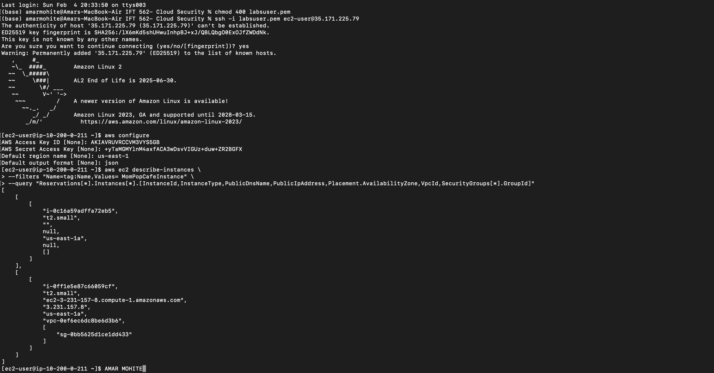

## How to make a modification to the lab policy using the AWS CLI

## How to add a parameter to the parameter store for allowing cookies on the website

1. On the AWS console navigate to Application management, then click Parameter store.
2. Create parameter and insert values like Name, Description, and value.
3. 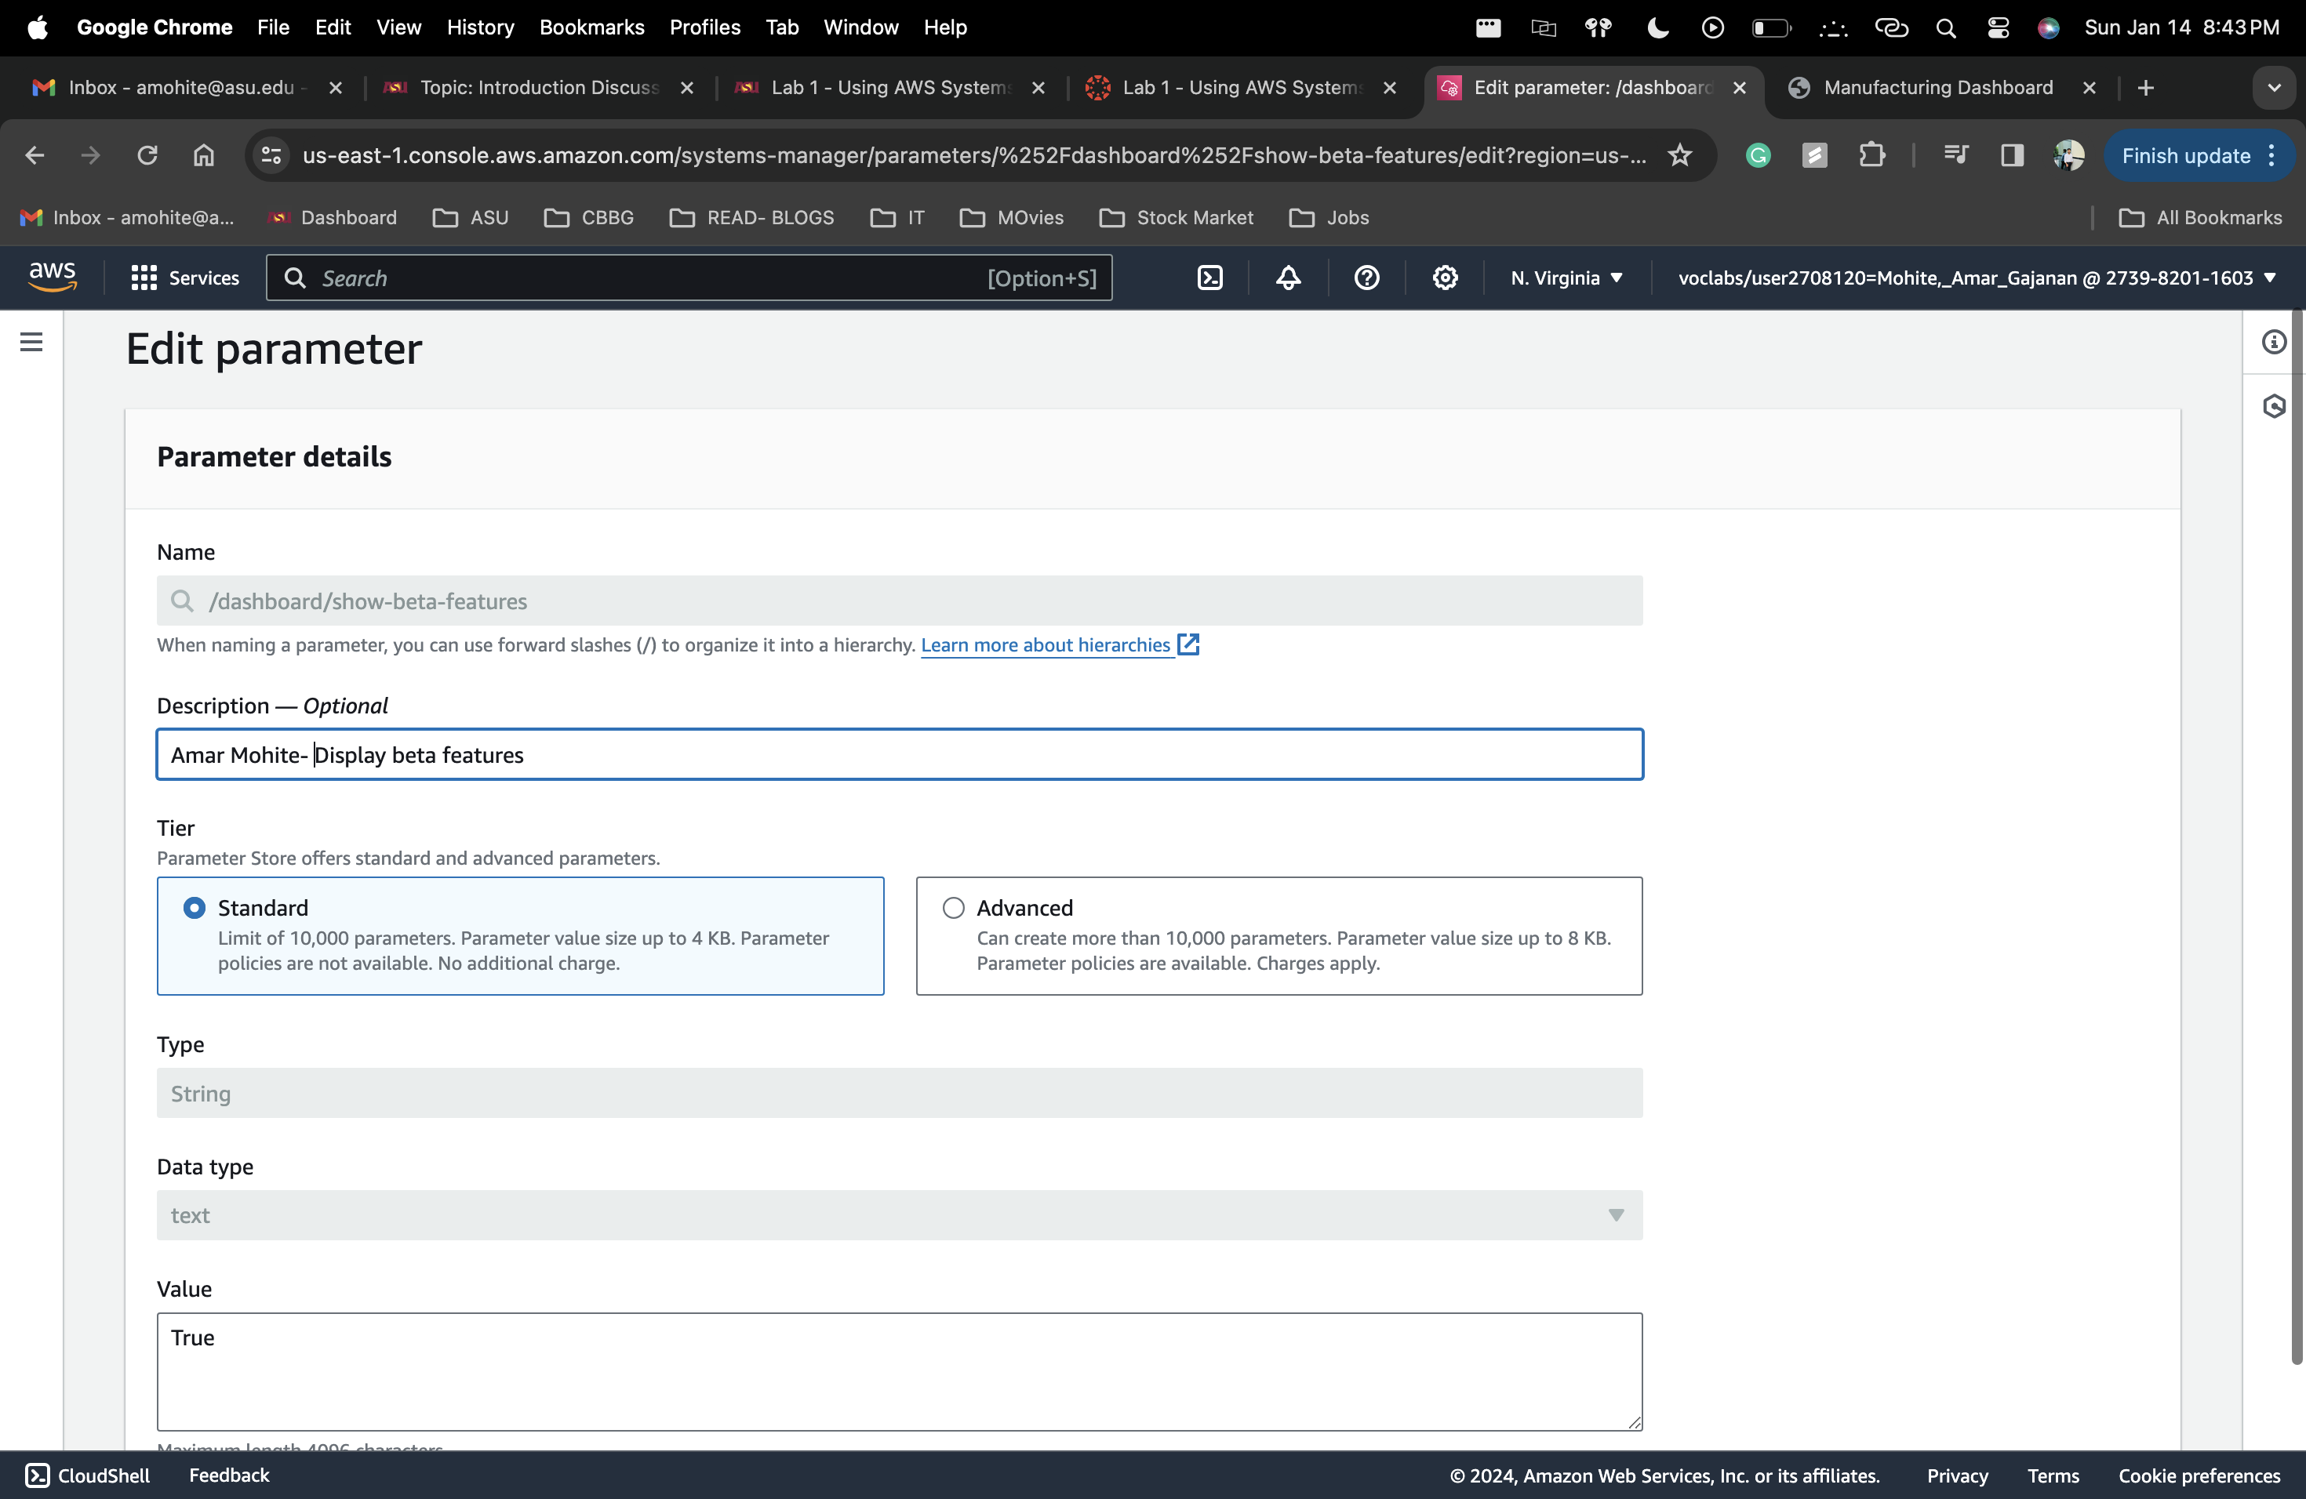

## How to connect to an EC2 instance to describe instances

1. In the AWS console navigate to EC 2 > EC2 instance > Session manager> Start Session >
2. On the command line type 🡪 aws ec2 describe-instances
3. 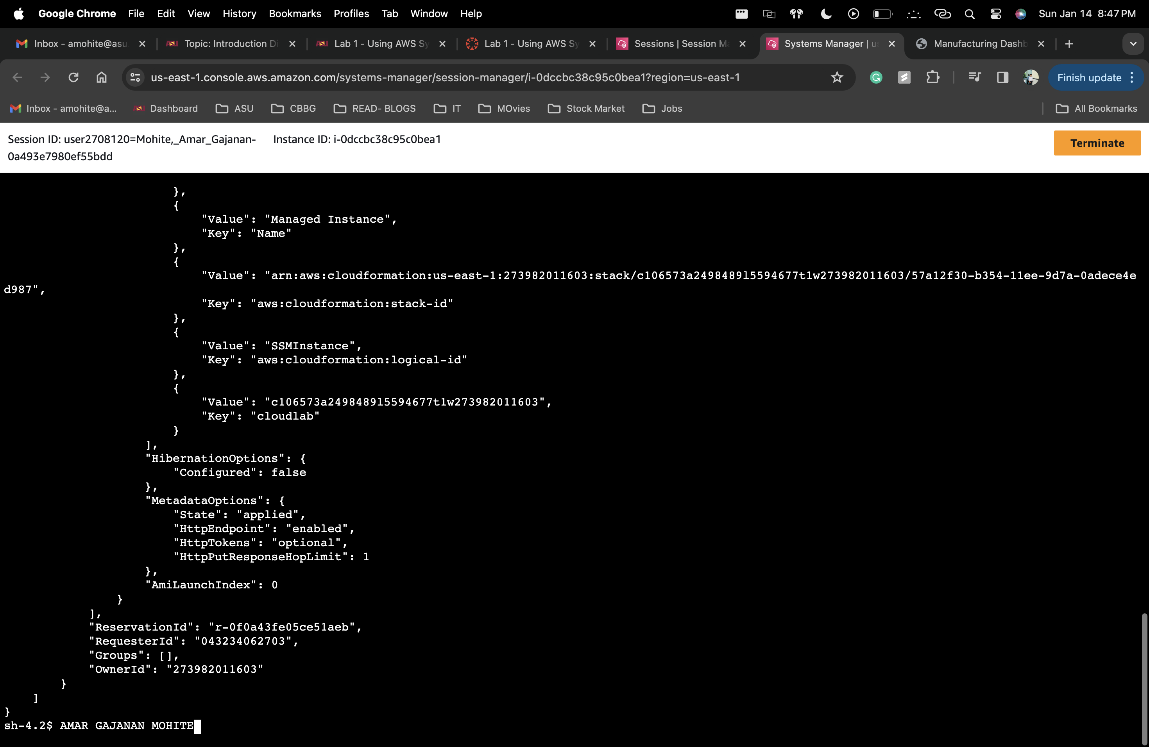

## How to launch an EC2 instance

1. There are different ways of launching an EC2 Instances – a) Management Console b) AWS CLI
2. We will Start with Management Console
3. Management Console > Create Instance >
4. Provide Name. (Desired EC2 Instance name)
5. Application and OS Image - Linux, Windows, MacOs etc
6. Choose an Instance type ( e.g. t2.micro)
7. Create or choose a key pair which allows you to connect on your terminal
8. Network configuration – VPC, Subnet, Security group
9. Configure storage, Advanced details
10. Finally Launch Instance

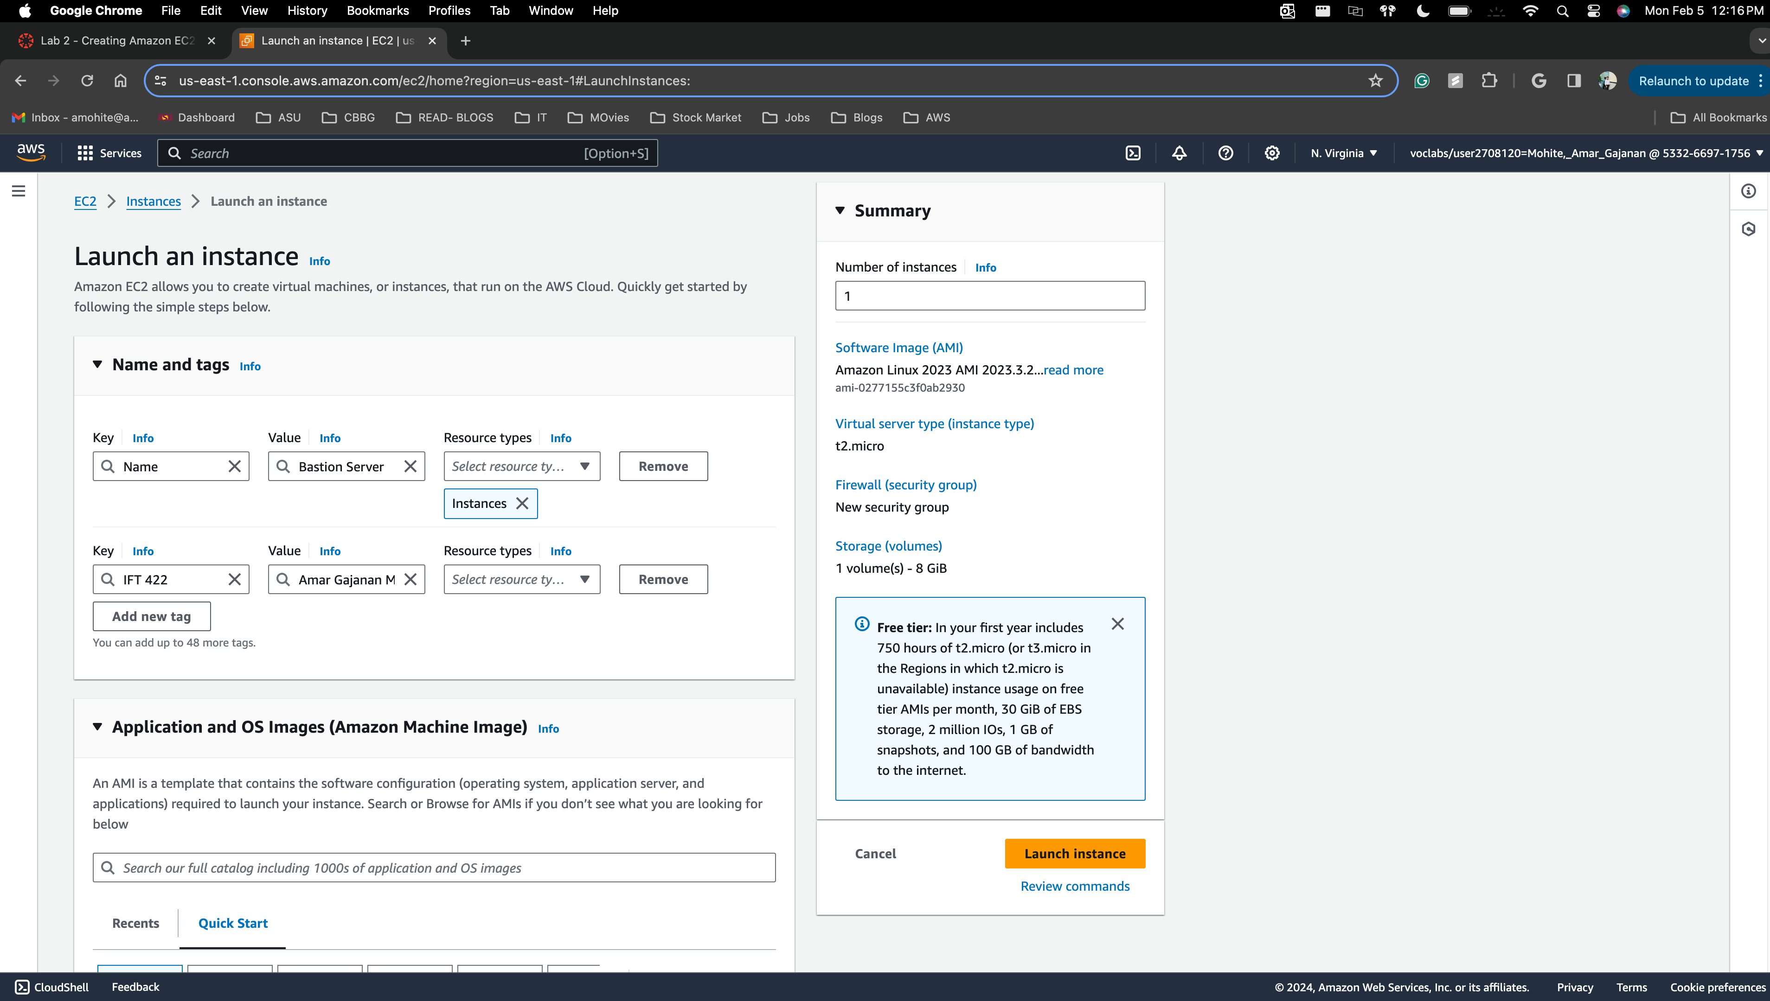

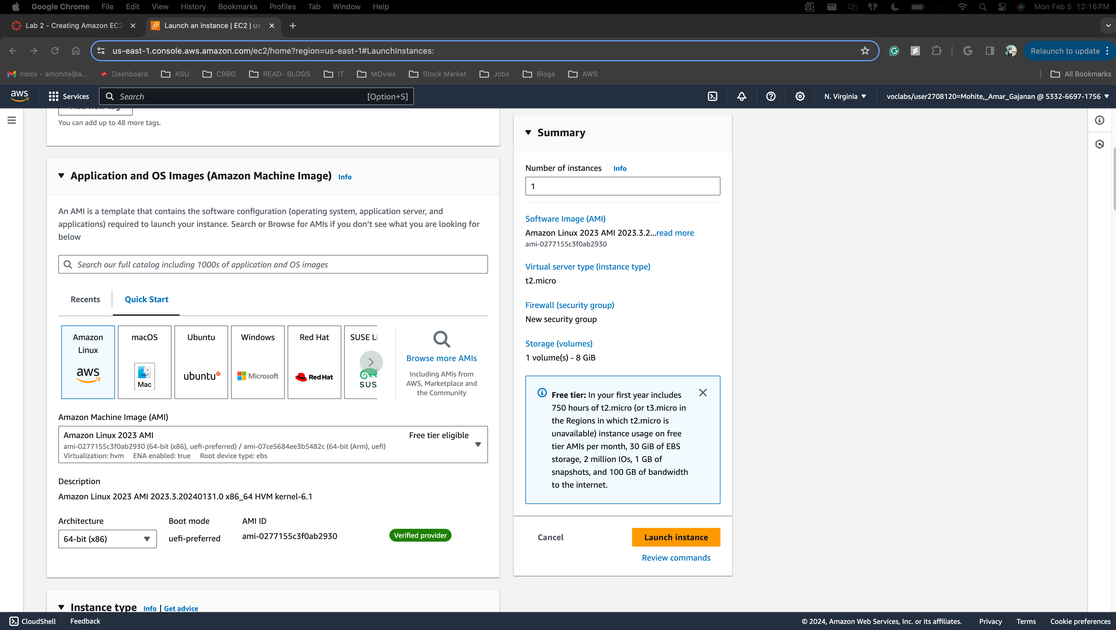

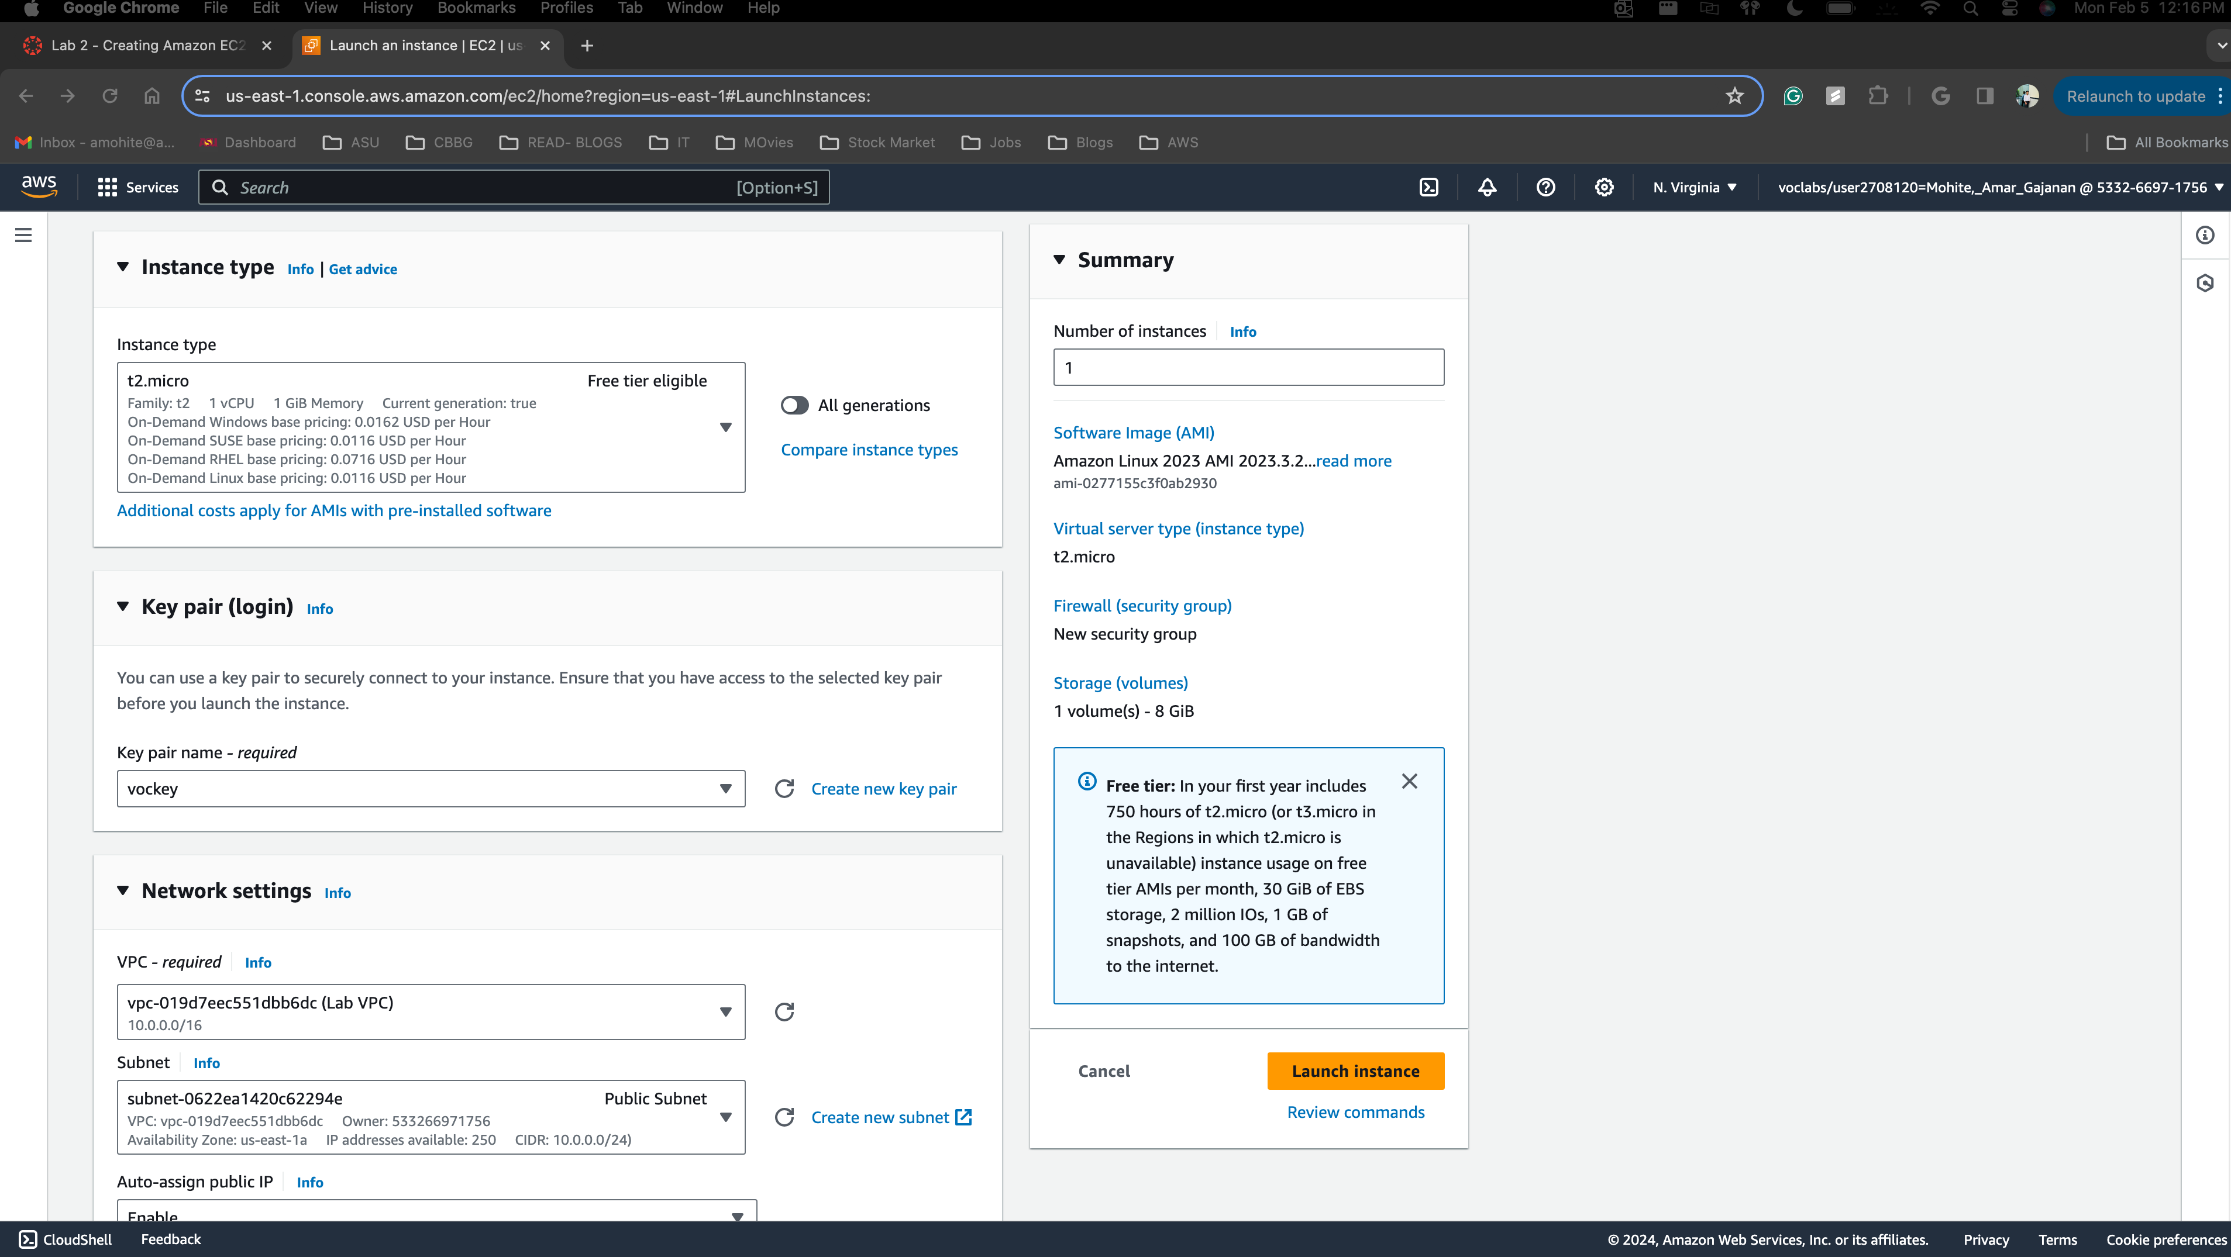

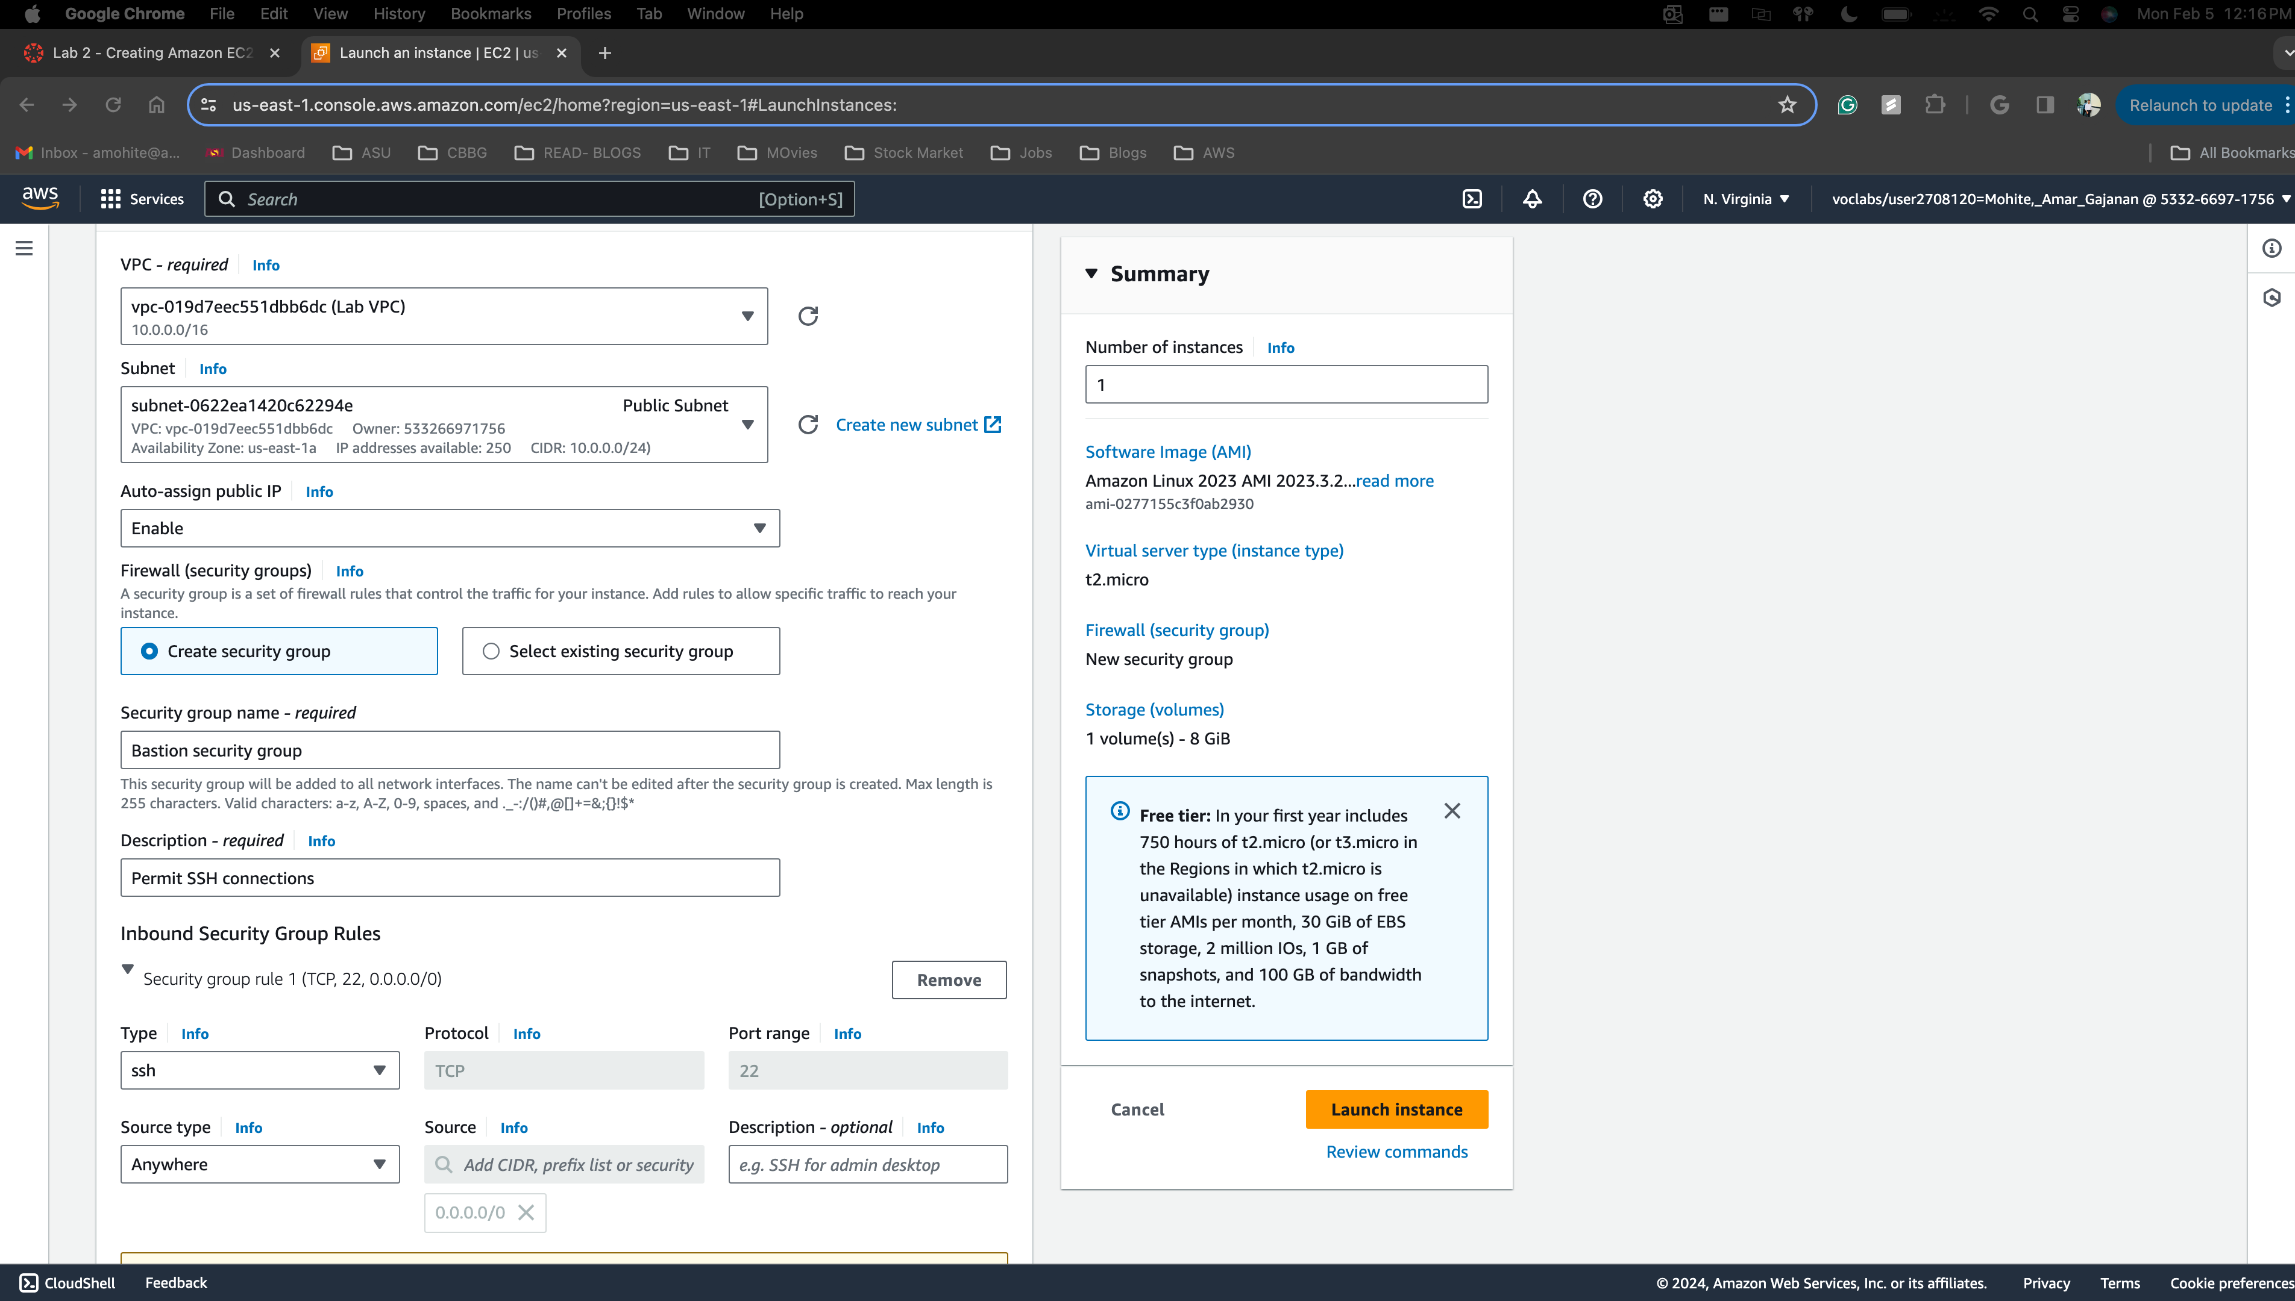

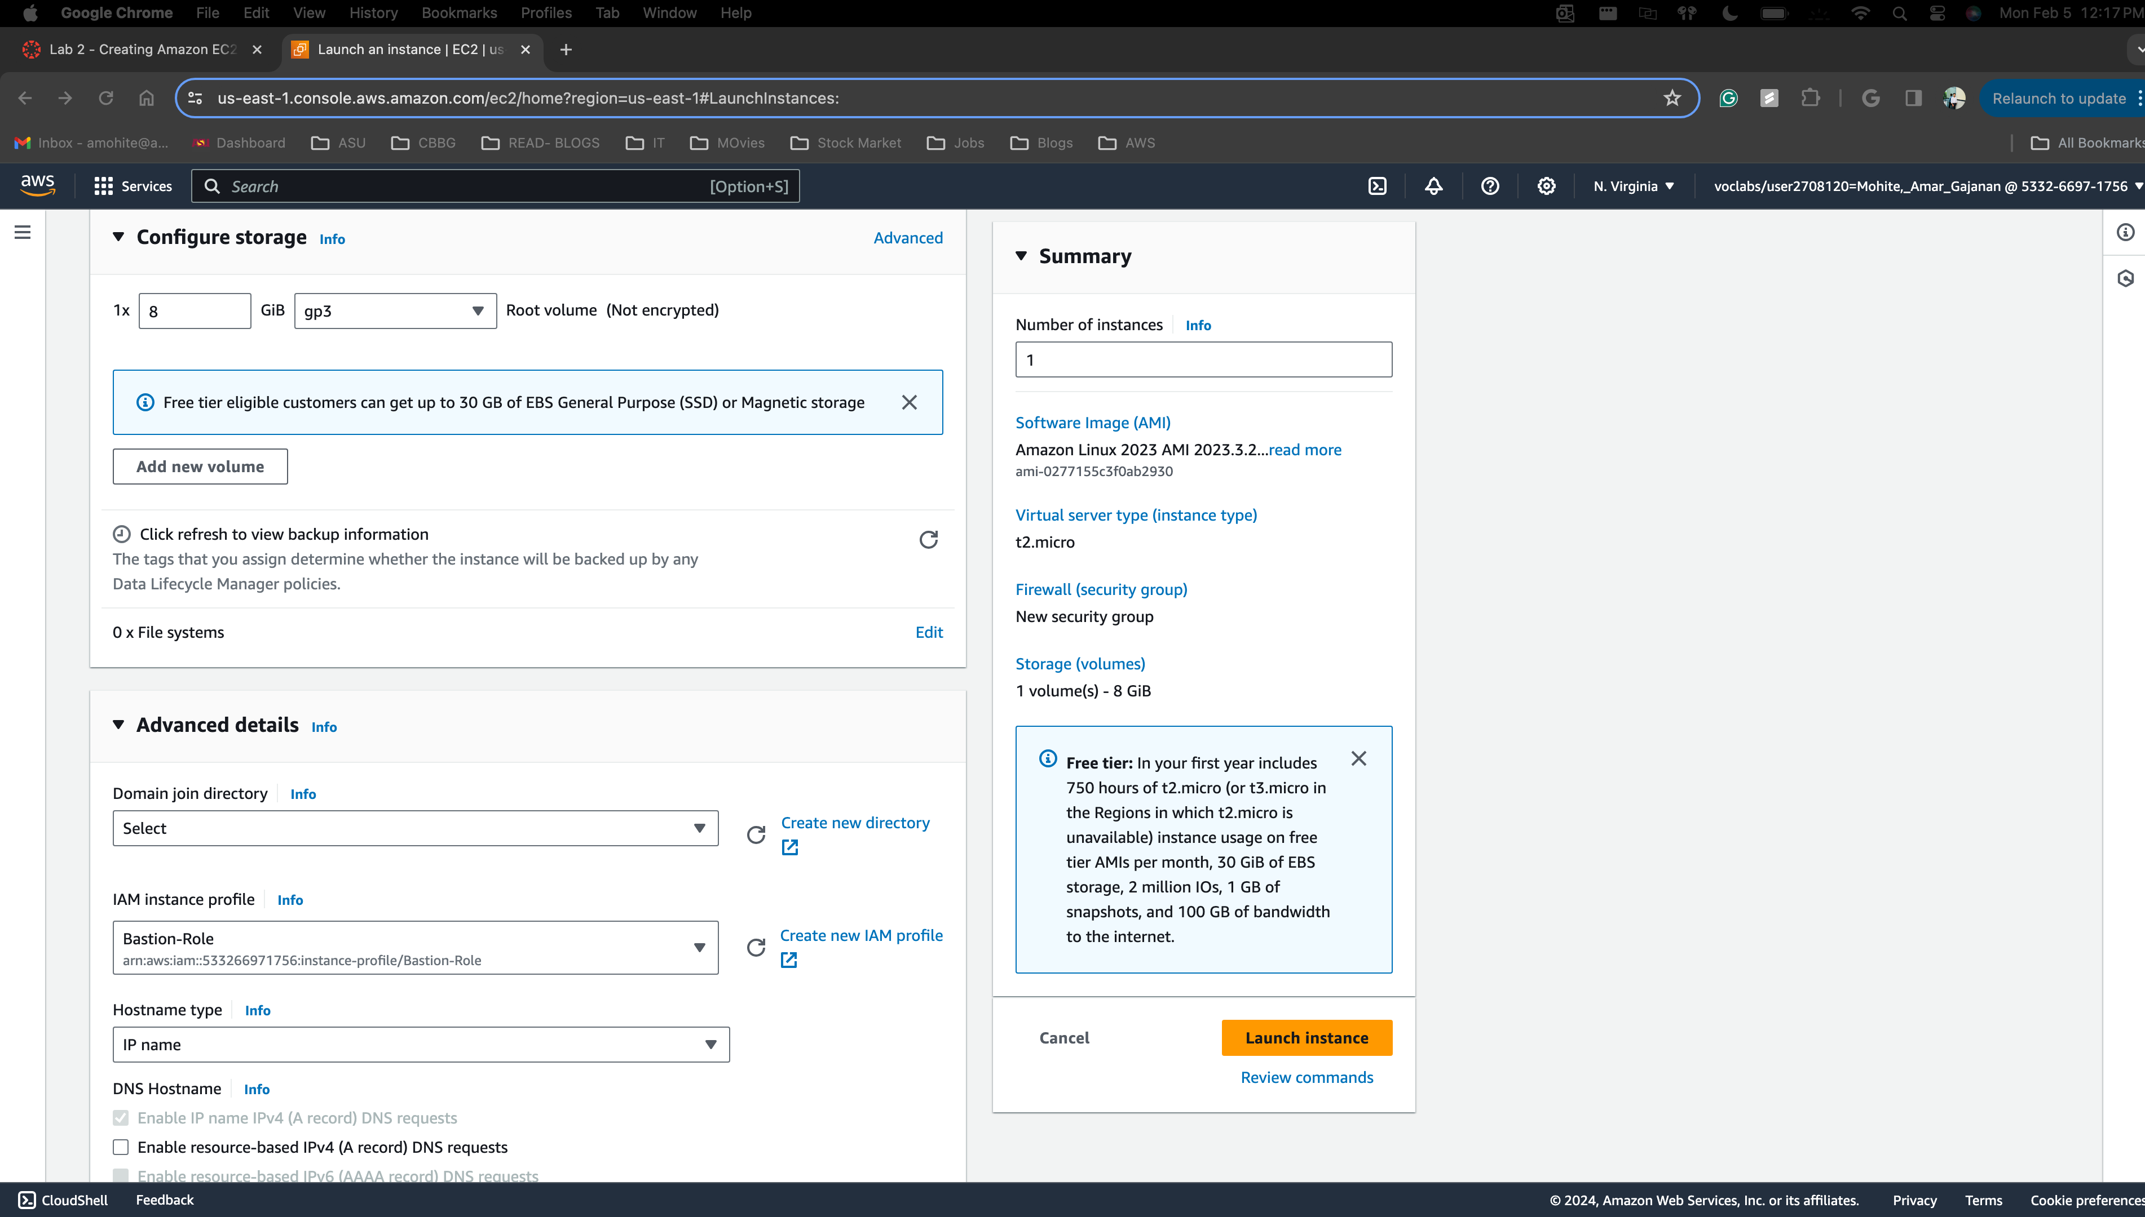

AWS CLI-

1. Connect to the AWS account
2. Run the below command and your instance will be up and running
3. INSTANCE=$(\
4. aws ec2 run-instances \
5. --image-id $AMI \
6. --subnet-id $SUBNET \
7. --security-group-ids $SG \
8. --user-data file:///home/ec2-user/UserData.txt \
9. --instance-type t2.micro \
10. --tag-specifications 'ResourceType=instance,Tags=[{Key=Name,Value=Web Server}]' \
11. --query 'Instances[*].InstanceId' \
12. --output text \
13. )
14. echo $INSTANCE

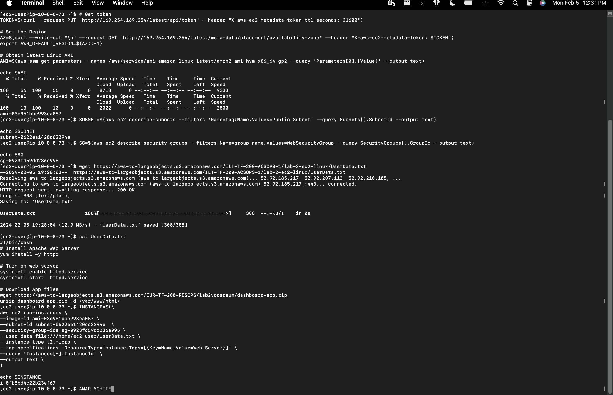

## How to fix a misconfigured web server with (________) issue

## How to change the AMI instance on the create-lamp-instance.sh script

1. Connect the AWS CLI and navigate to create-lamp-instance.sh a bash file.
2. Run the command 🡪 vi create-lamp-instance.sh
3. Vi command will open the command-line editor
4. Make the necessary changes and save it using :w command and exit by :q
5. 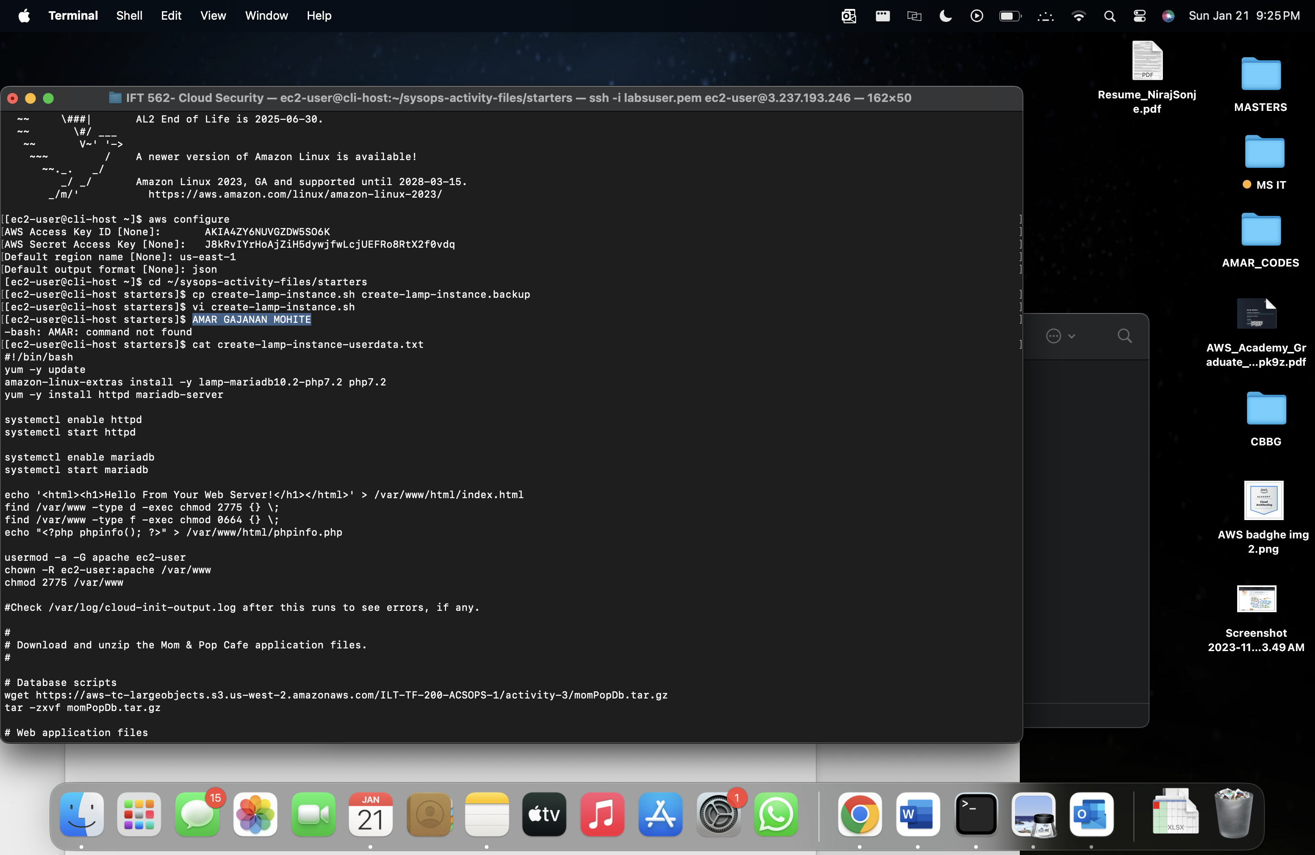
6. 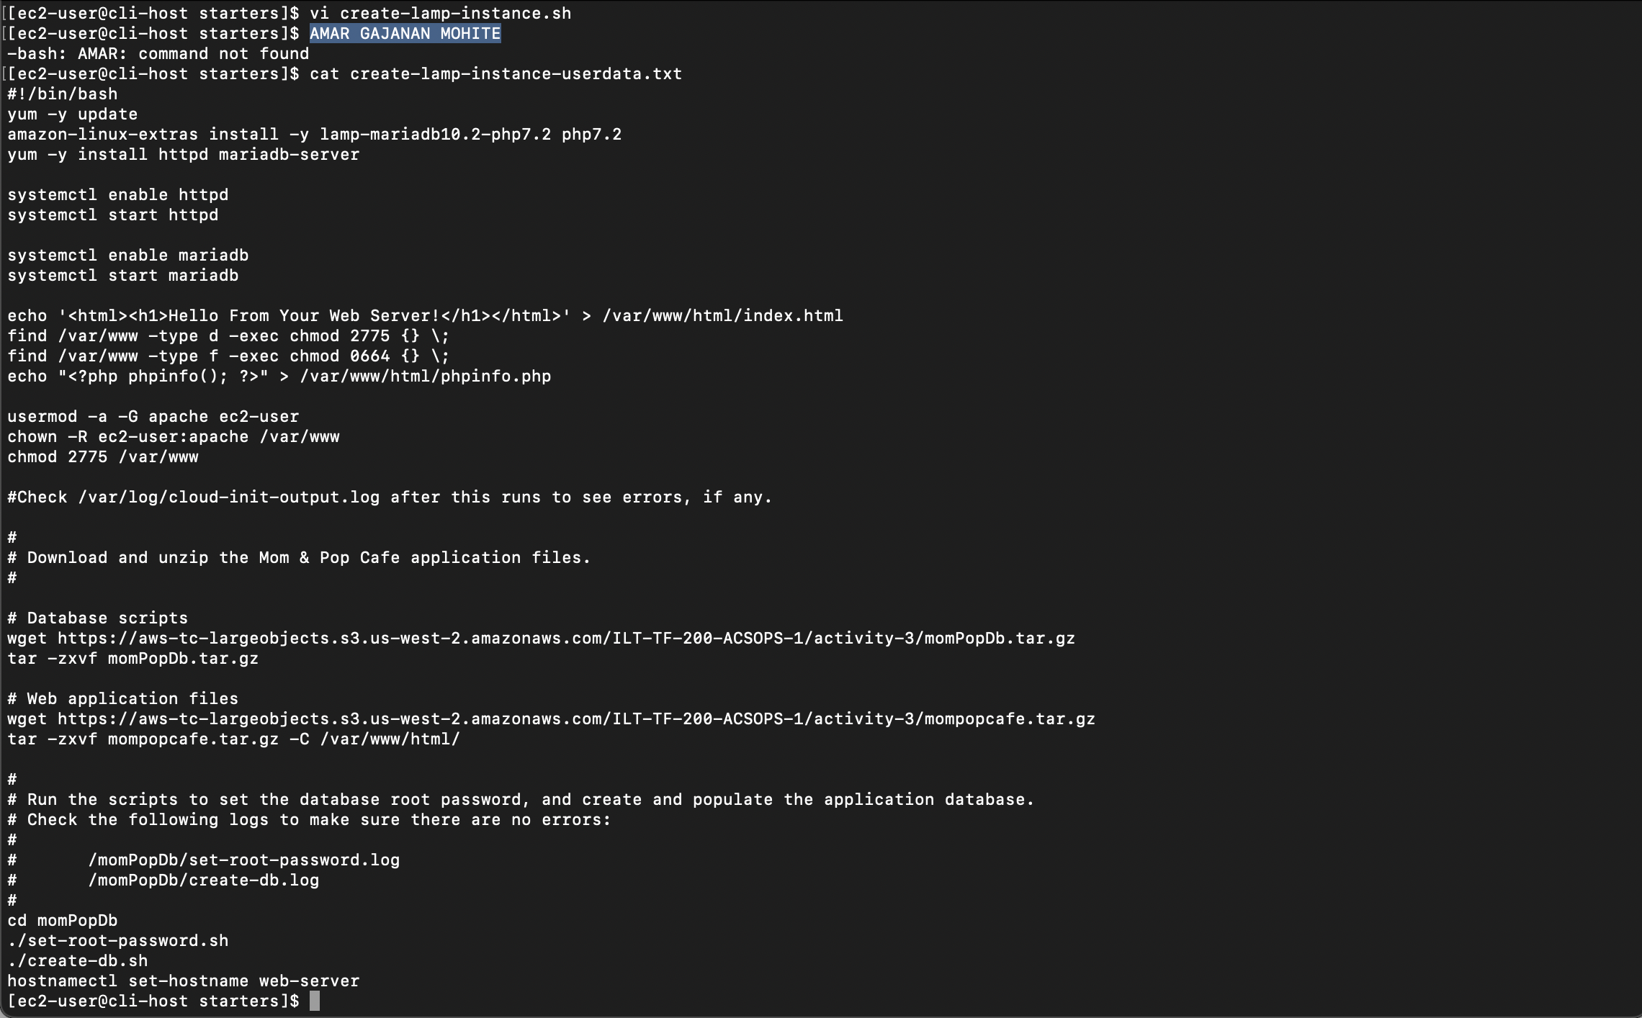

## How to tail a log in Linux

1. tail -f /path/to/logfile
2. 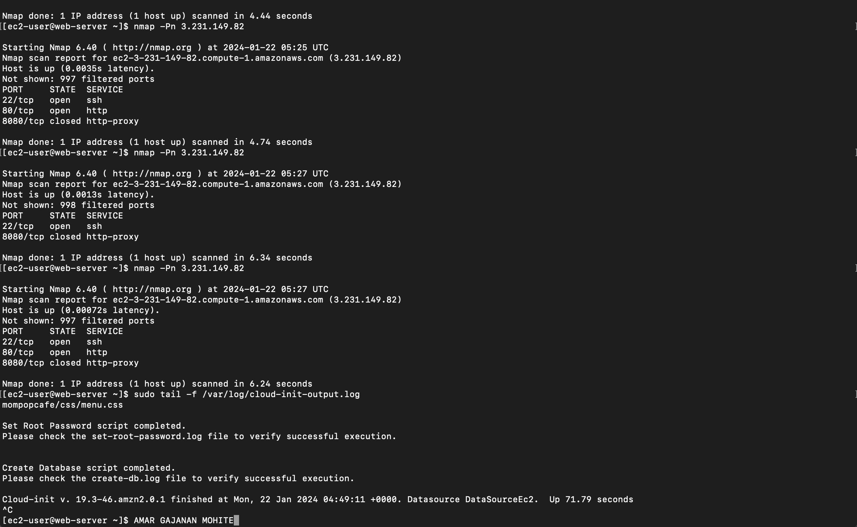

## How to create an Auto Scaling Group in the AWS UI

## How to create a Route 53 health check

## How to create an Amazon RDS instance using the CLI

1. We use the following commands to create AWS RDS instance using CLI
2. aws rds create-db-instance \ rds referes to AWS RDS, and followed command to create a database instance
3. --db-instance-identifier <name of the db instance> \
4. --engine mariadb \
5. --engine-version 10.6.14 \
6. --db-instance-class db.t2.micro \
7. --allocated-storage 20 \
8. --availability-zone < Availability Zone> \
9. --db-subnet-group-name "MSubnet Group" \
10. --vpc-security-group-ids <database Group ID> \
11. --no-publicly-accessible \
12. --master-username <user-name> --master-user-password '****'

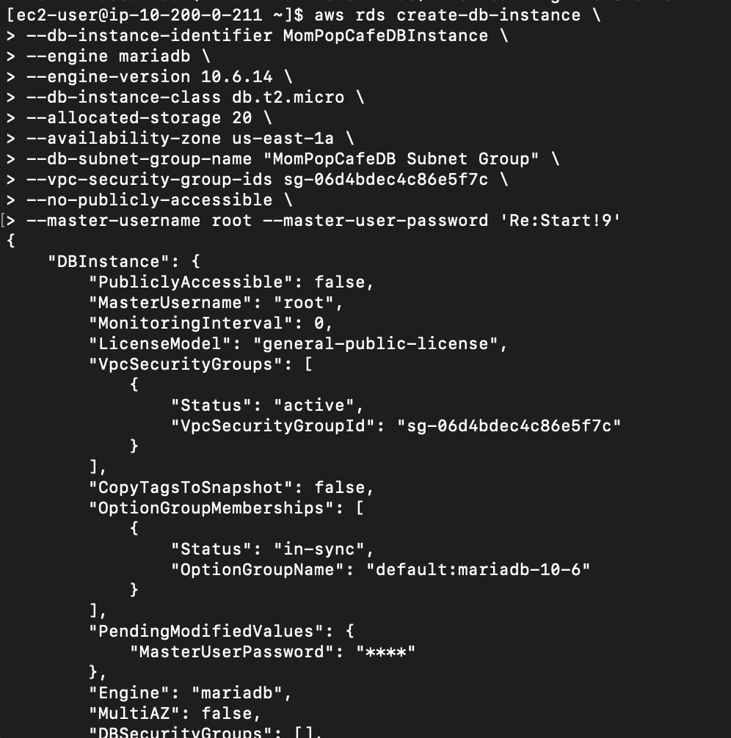

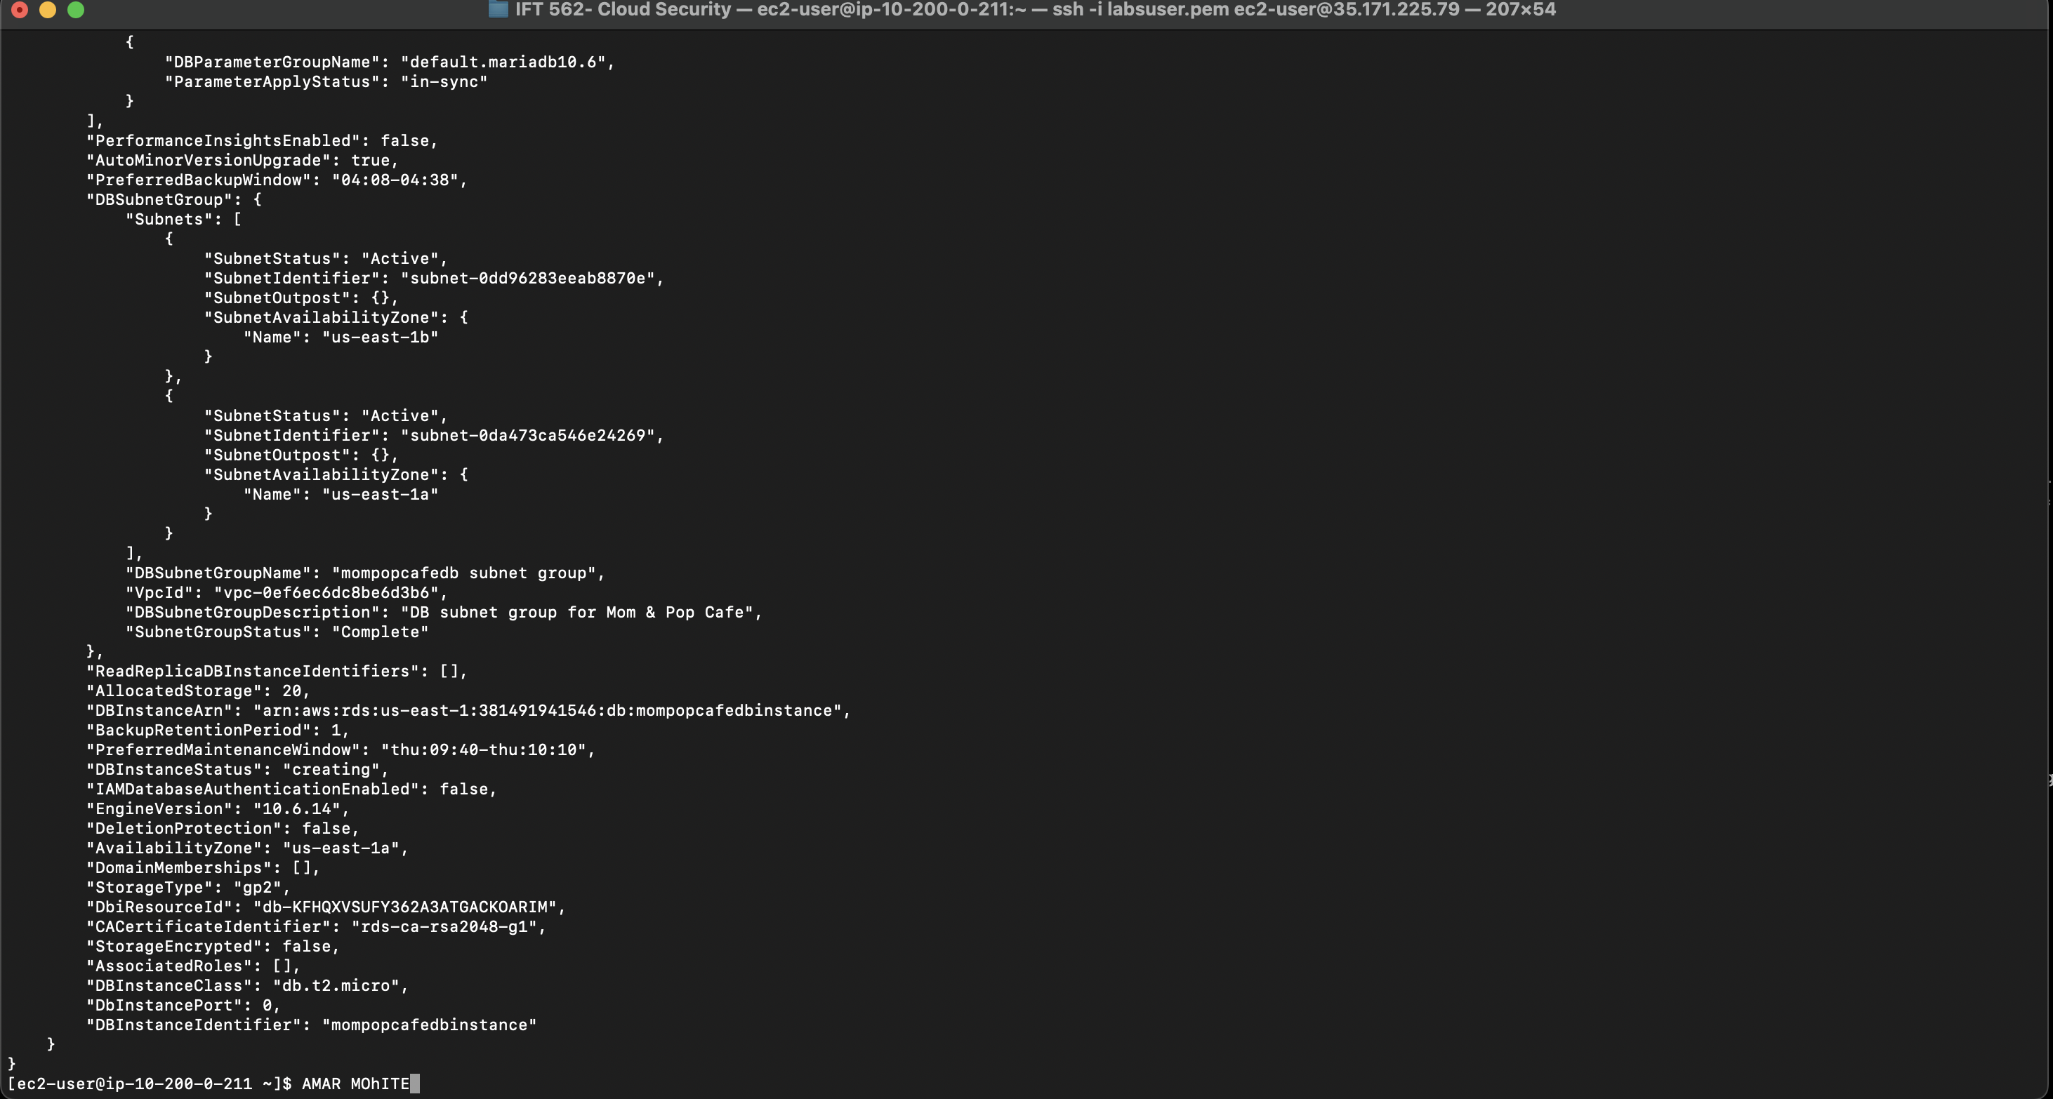

## How to collect information about an instance

1. We can get information about any instance by applying filters and query
2. aws ec2 describe-instances \
3. --filters "Name=tag:Name,Values= MomPopCafeInstance" \
4. --query "Reservations[*].Instances[*].[InstanceId,InstanceType,PublicDnsName,PublicIpAddress,Placement.AvailabilityZone,VpcId,SecurityGroups[*].GroupId]"



## How to create two subnets in a subnet group via the AWS CLI

1. aws rds create-db-subnet-group \
2. --db-subnet-group-name " Subnet Group" \
3. --db-subnet-group-description "DB subnet group for Mom & Pop Cafe" \
4. --subnet-ids < Private Subnet 1 ID> < Private Subnet 2 ID> \
5. --tags "Key=Name,Value= DatabaseSubnetGroup"
6. In this code which I got from Activity 6. We can substitute the subnet IDs in the line 4 instead of < Private Subnet 1 ID> < Private Subnet 2 ID>
7. After running this code we can create a subnet group which has 2 subnets

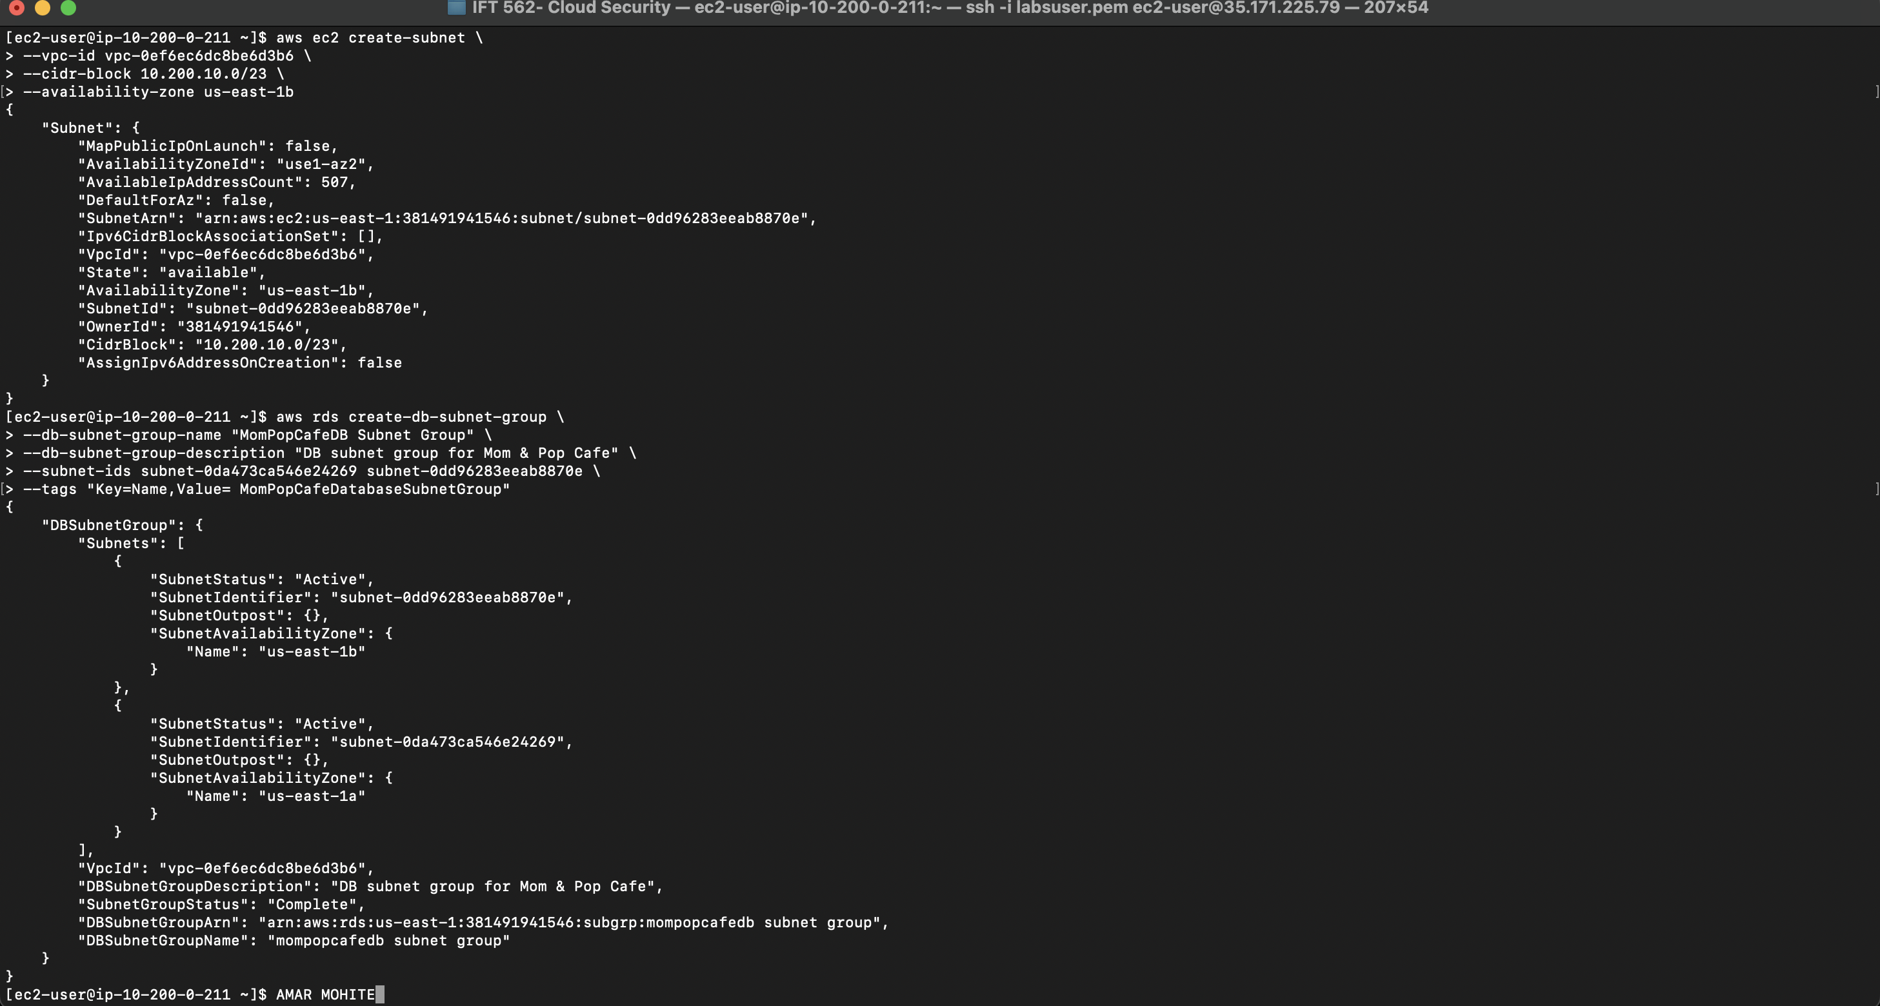

## How to use the mysqldump tool to take a backup of a SQL database and restore it on another SQL instance

## How to enable VPC Flow Logs via the command line interface

1. To enable VPC Flow logs, login to AWS CLI
2. We have to create a S3 bucket where we need to save our logs

Command- aws s3api create-bucket --bucket flowlog#### --region <region> --create-bucket-configuration LocationConstraint=<region>

Flowlog###- Bucket name

<region> - region where you need to create the bucket

1. To create a VPC flowlog run the following command and it will get created inside your S3 bucket. Later, you can access through CLI.

Command- aws ec2 create-flow-logs --resource-type VPC --resource-ids <vpc-id> --traffic-type ALL --log-destination-type s3 --log-destination arn:aws:s3:::<flowlog####>

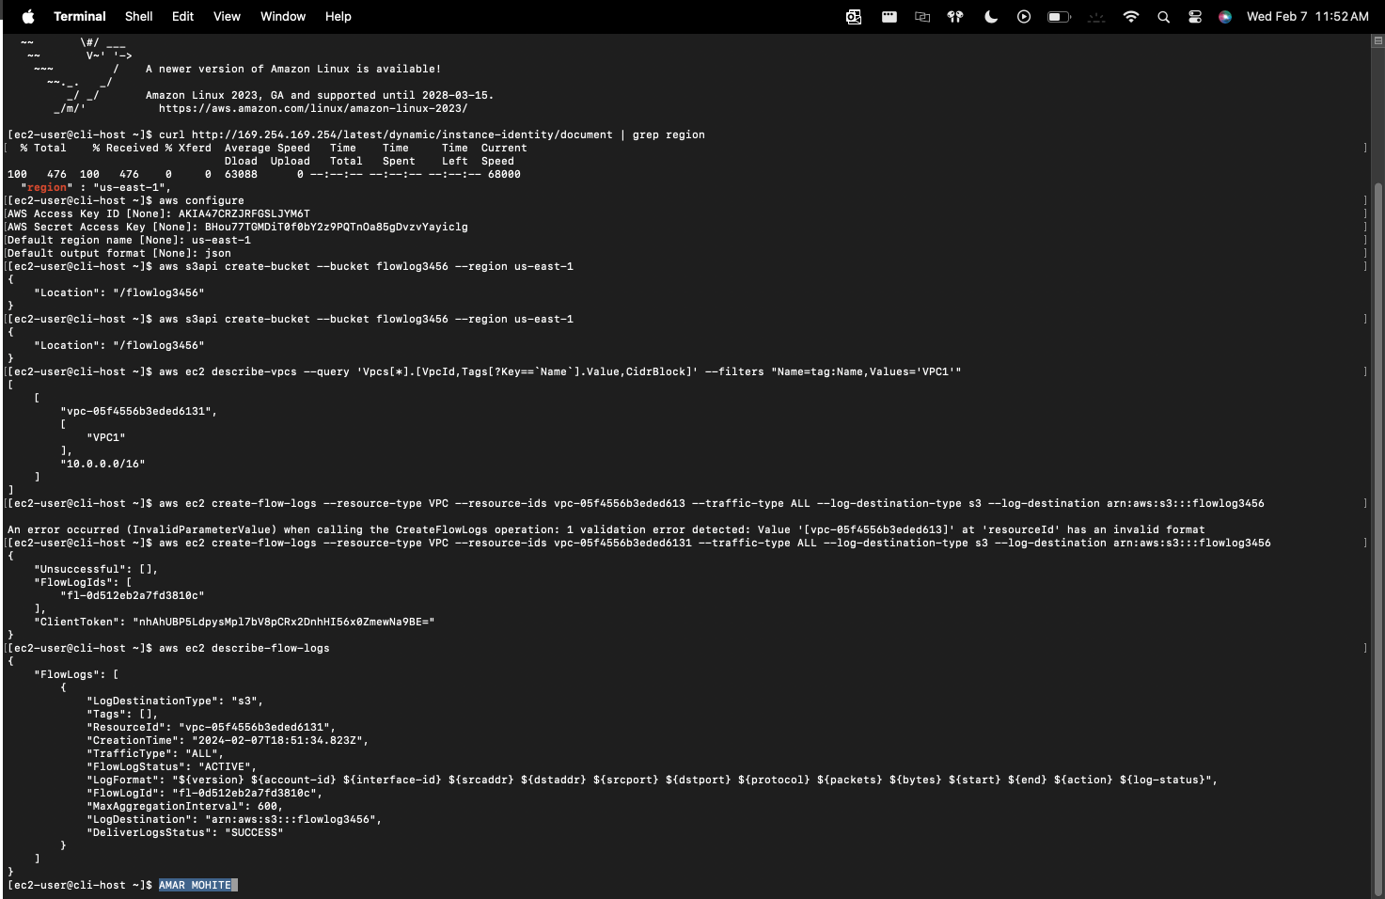

## How to troubleshoot network connectivity on an instance

1. To troubleshoot network there are different methods and approaches.
2. Let’s figure out what ports are open to the EC2 instance by using map function

sudo yum install -y nmap (this command will download the nmap function into out system)

nmap <WebServerIP> ( gives the list of ports open)

1. Secondly, check the security group details by using = aws ec2 describe-security-groups

Use group id for detailed connectivity and see if the connectivity is good.

1. Thirdly, check the route tables that are associated with the VPC= aws ec2 describe-route-tables --filter "Name=association.subnet-id,Values='<VPC1PubSubnetID>'"
2. Check the network ACL (network access control list) by using = aws ec2 describe-network-acls --filter "Name=association.subnet-id,Values='VPC1PublicSubnetID'" --query 'NetworkAcls[*].[NetworkAclId,Entries]'

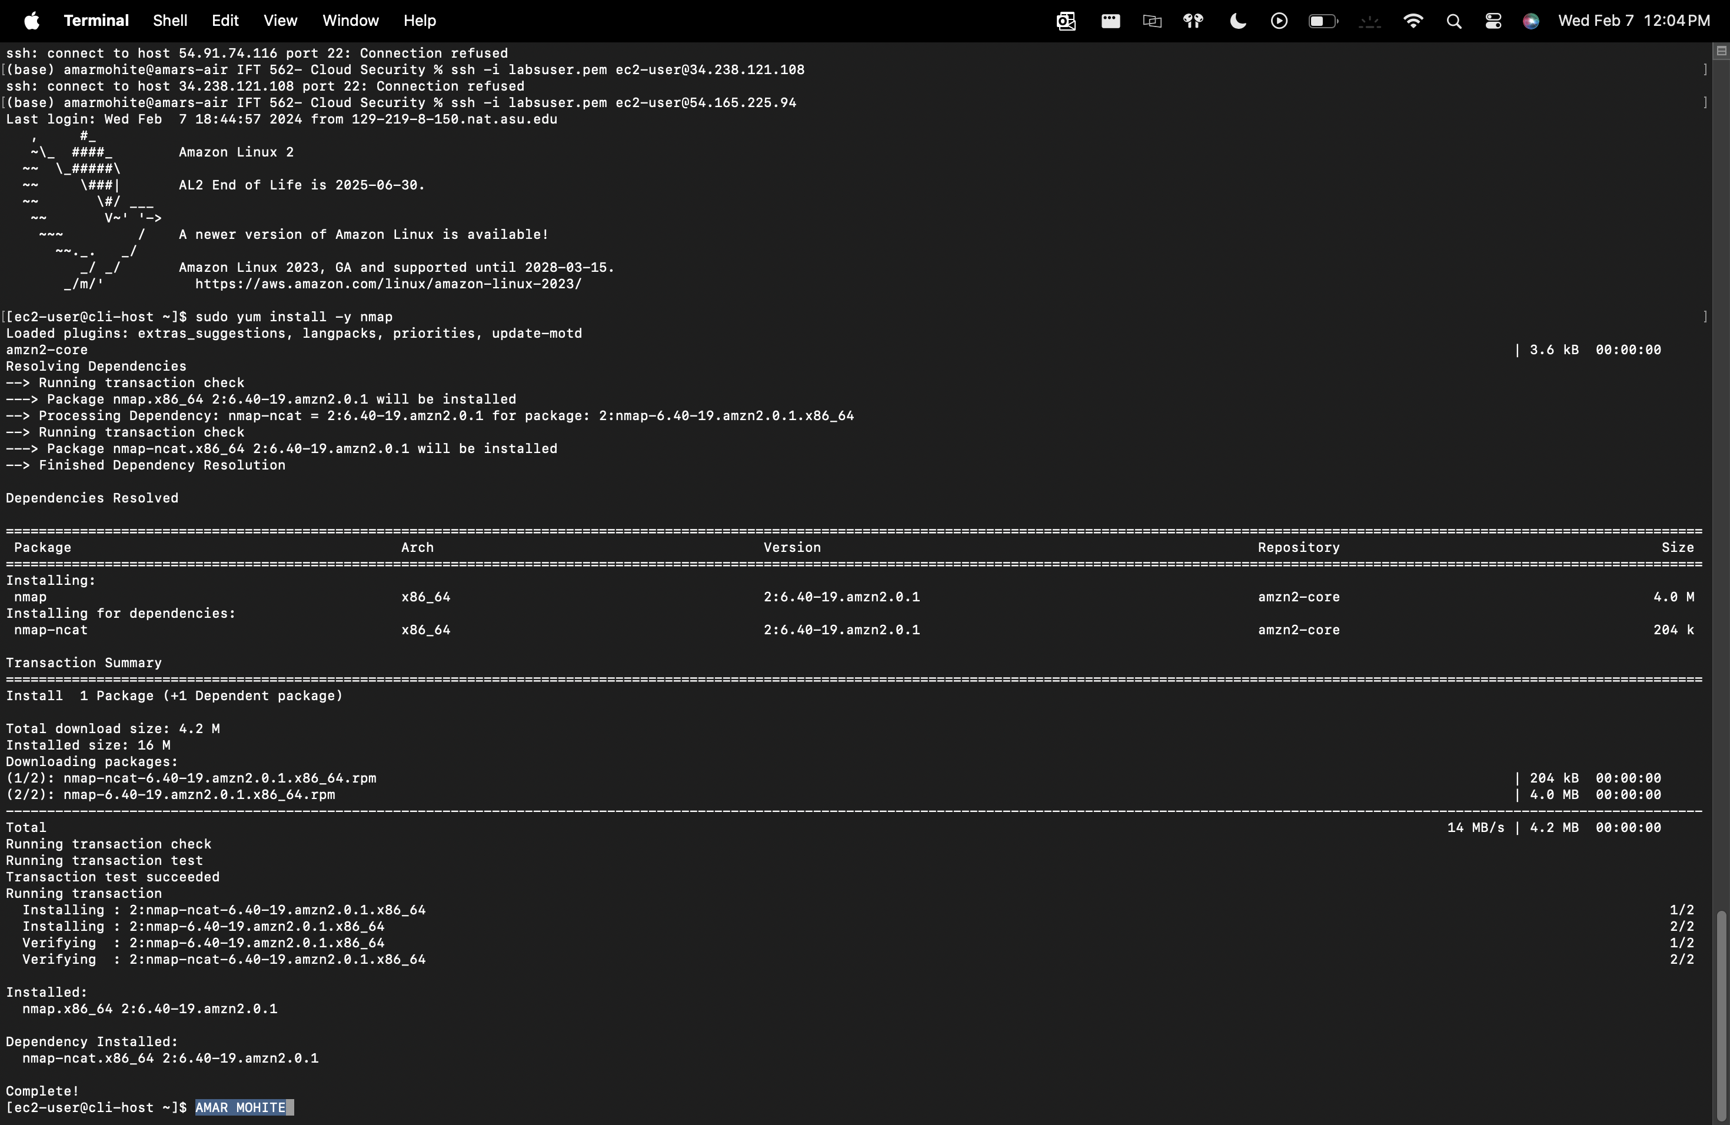

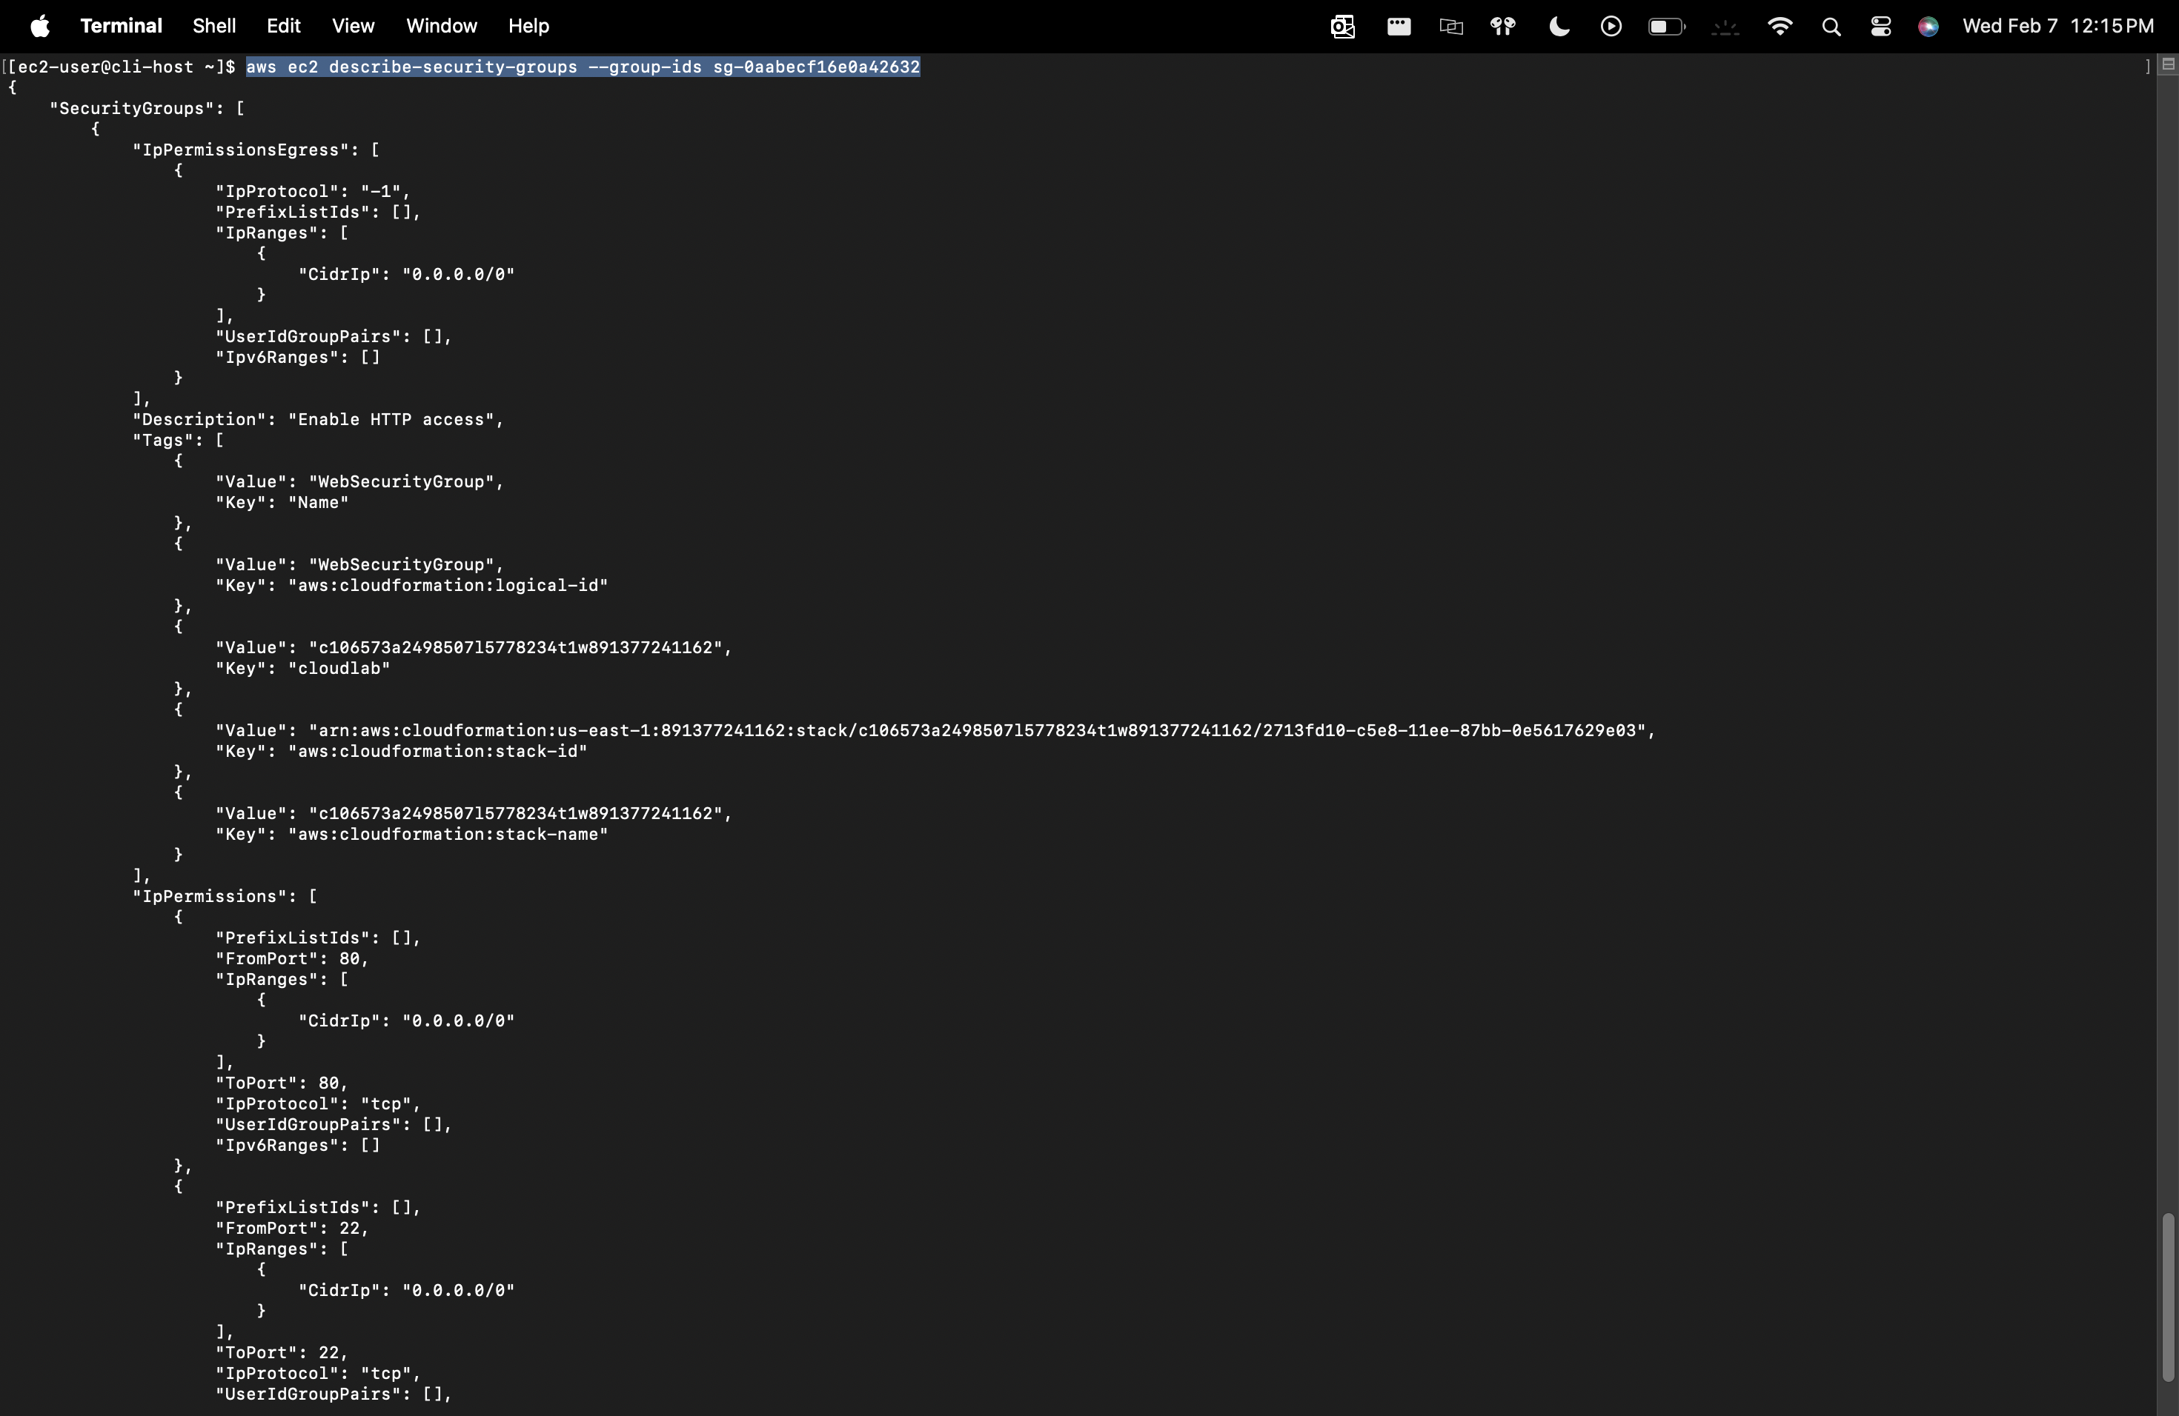

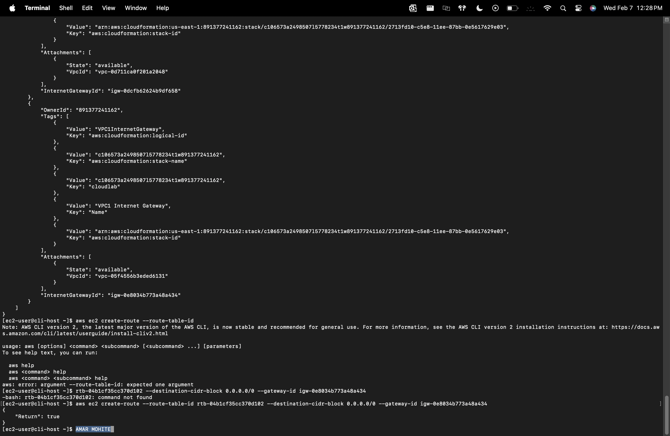

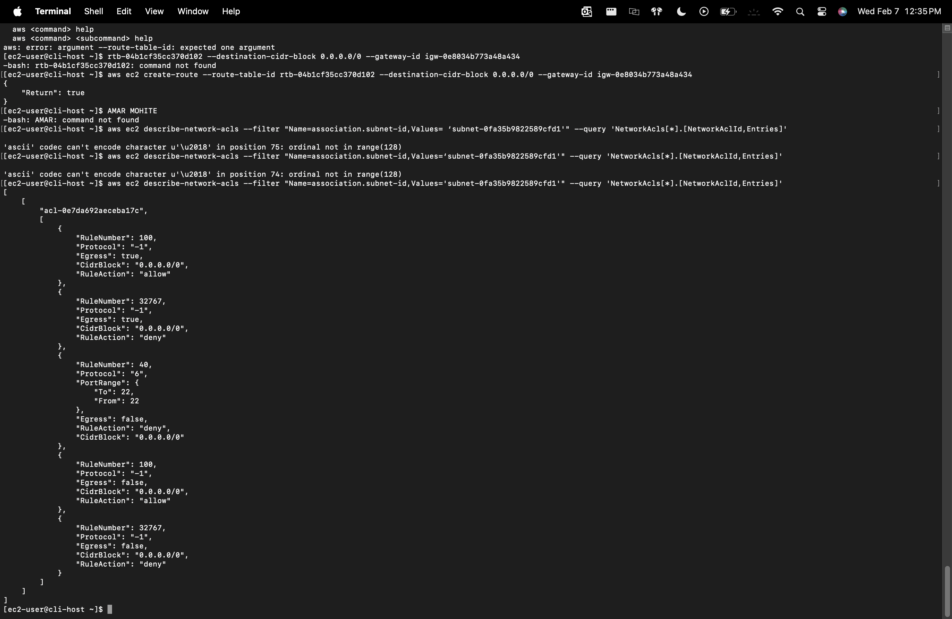

HOW TO SEE THE VPC LOGS ON AWS CLI:-

1. Download the flowlogs from AWS S3- aws s3 cp s3://<flowlog####>/ . –recursive
2. Go inside the folders until you find a lot of files ending with .gz extension and unzip them using gunzip *.gz
3. Filter the rejected tags by using- grep -rn ' 22 ' . | grep REJECT
4. Likewise you can see the logs and troubleshoot the network

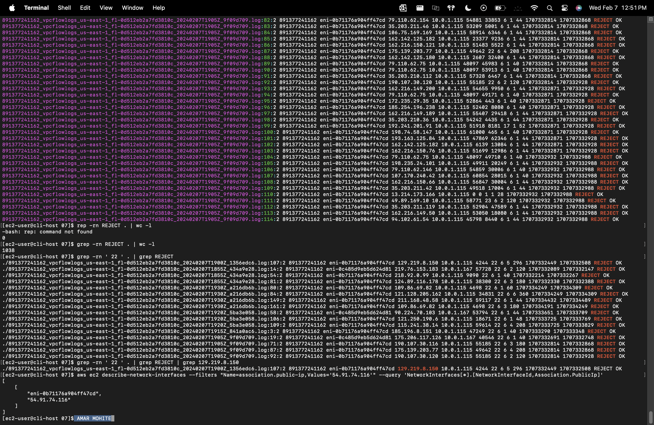

## How to take a snapshot of an EBS volume

1. Lab 5

## How to synchronize files using the command line (aws s3api and aws s3)

1. Lab 5

## How to create a S3 bucket via the CLI

1. Act 8

## How to add an event notification to a S3 bucket

1. Act 8

## How to install the CloudWatch Agent

1. Lab 6

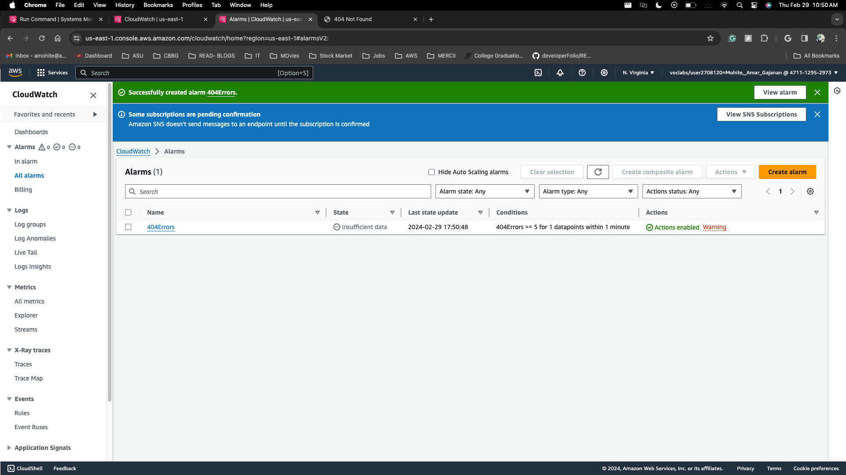

## How to create a CloudWatch Events/CloudWatch EventBridge notification rule

1. Lab 6

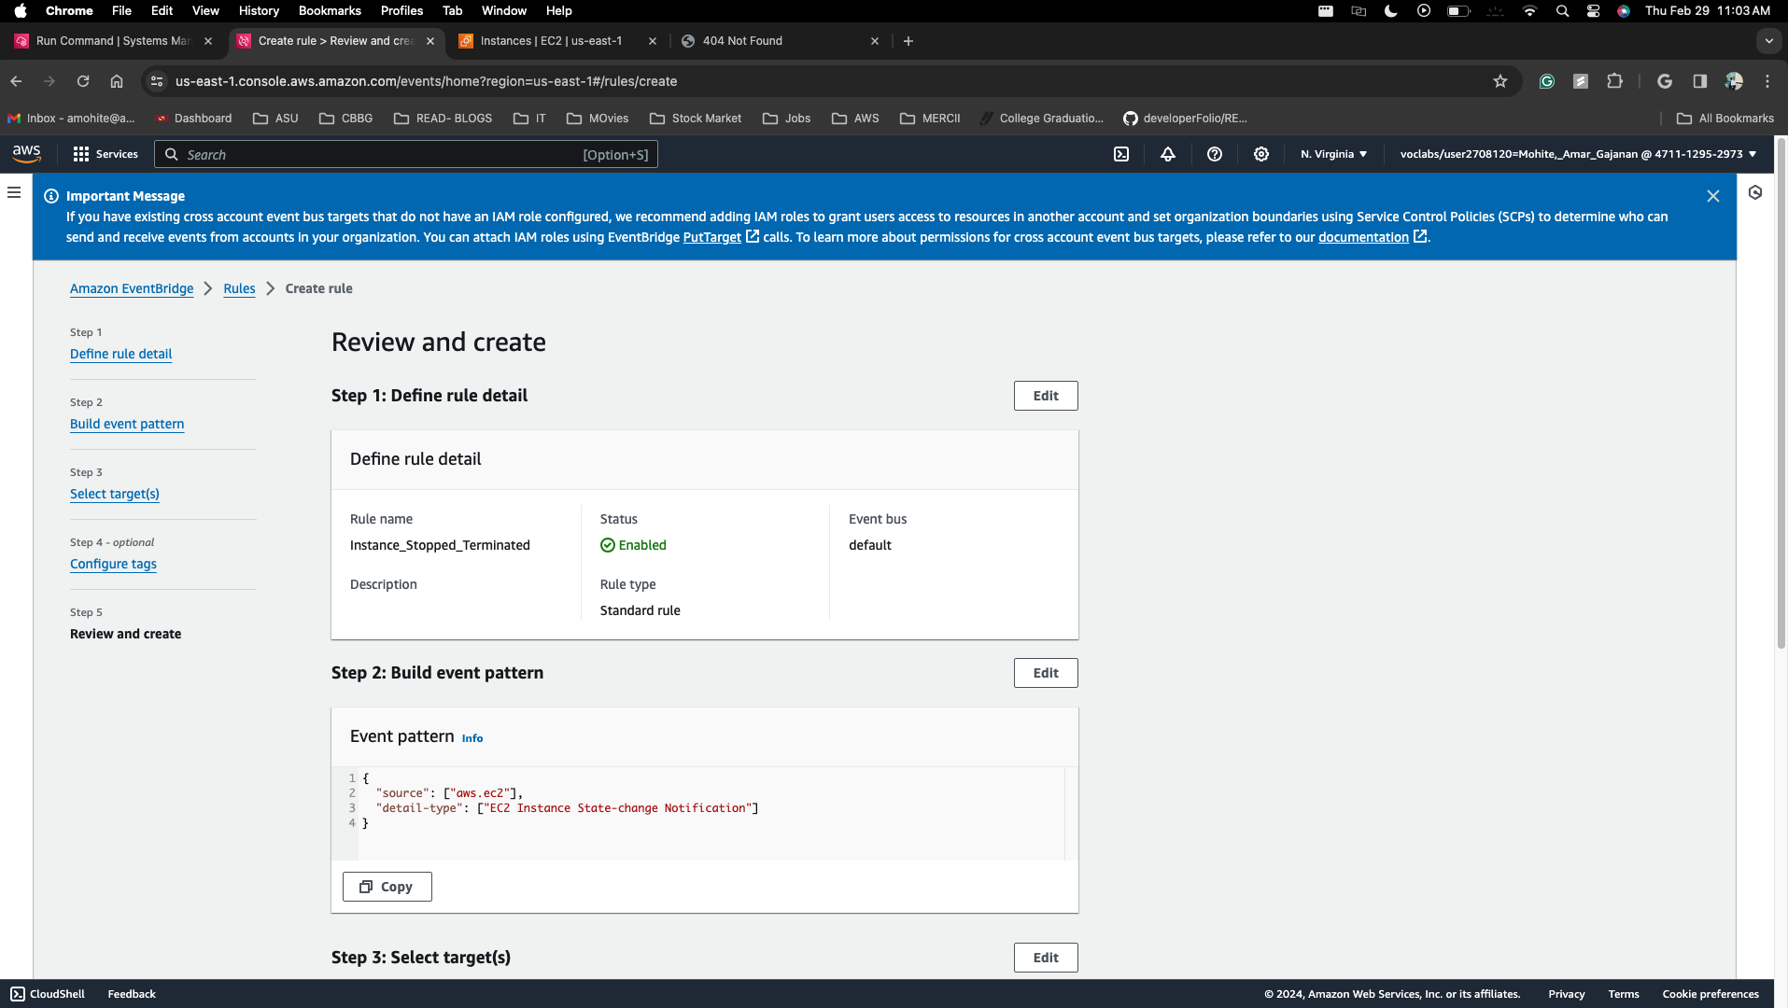

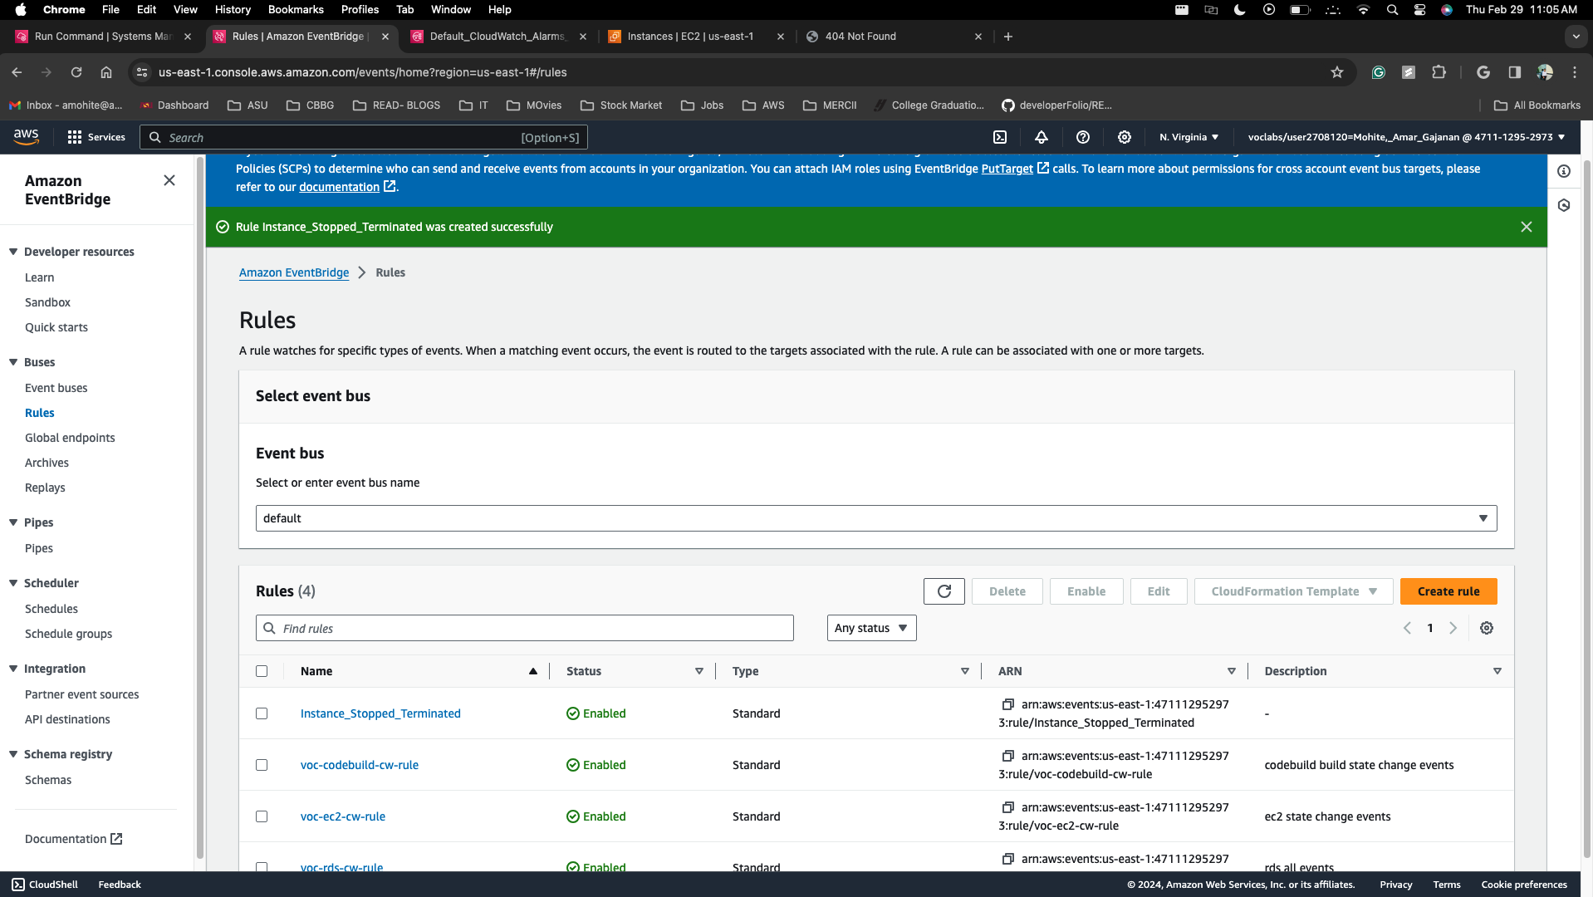

## How to use the prebuilt stopinator script to turn off instances with the tag value of your full name

1. Lab 7

## How to resize an EC2 instance using the AWS CLI

1. Act 10

## How to detect drift in a CloudFormation template

1. Act 11

## How to create an Amazon Athena table

1. Act 9

## How to manually review access logs to find anomalous user activity

1. Act 9

## How to create a batch file to update the café website to change its colors

1. Act2

## How to create a Lambda Layer and add it to a Lambda function

## How to create a Lambda function from a prebuilt package

## How to setup a VPC

1.Lab 4

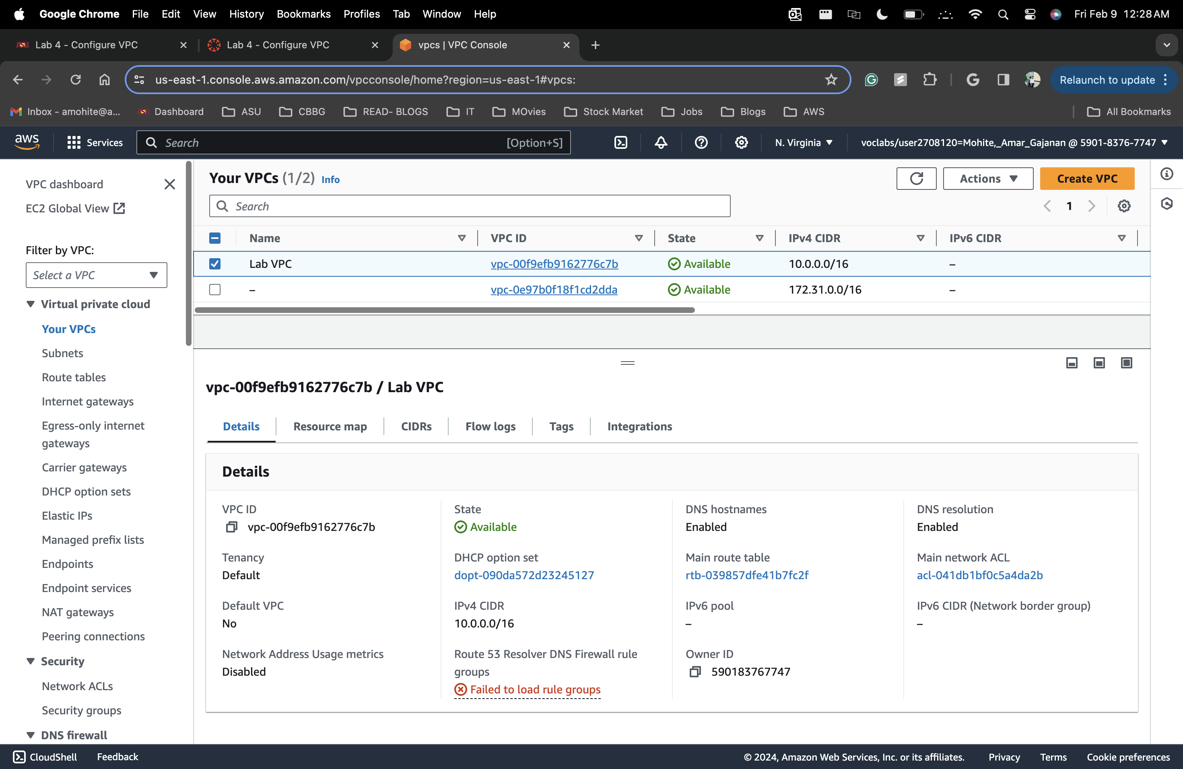

## How to add a bastion host (Linux) to the public subnet of a VPC to connect to instances in the private subnet

## How to setup IAM so a user can assume an IAM role to access a resource

## How to setup AWS Config to monitor resources

## How to add inbound rules to both security groups and network ACLs

1. Lab 4.1

## How to encrypt the root volume of an existing EC2 instance

1. Lab 5.1

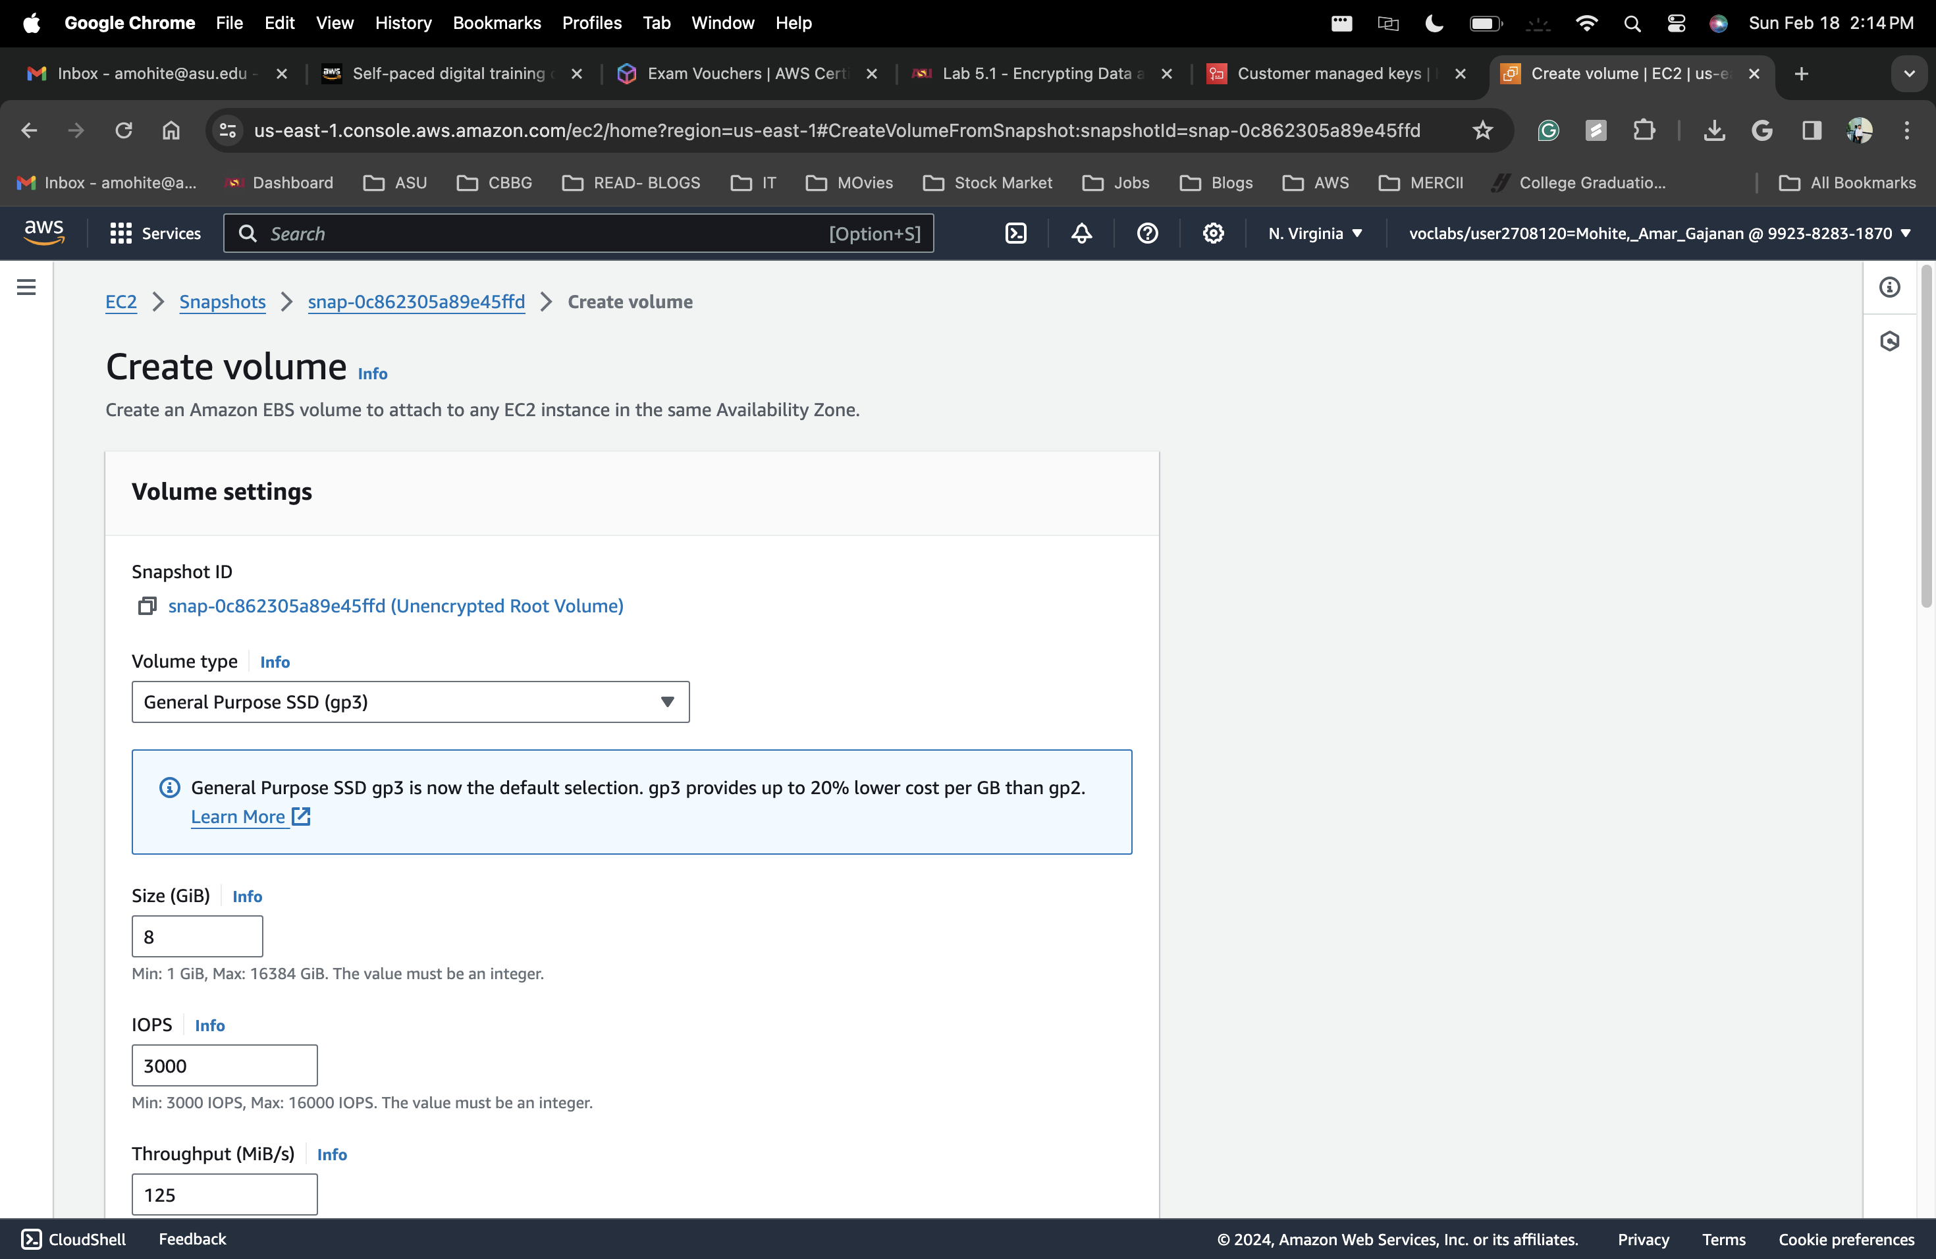

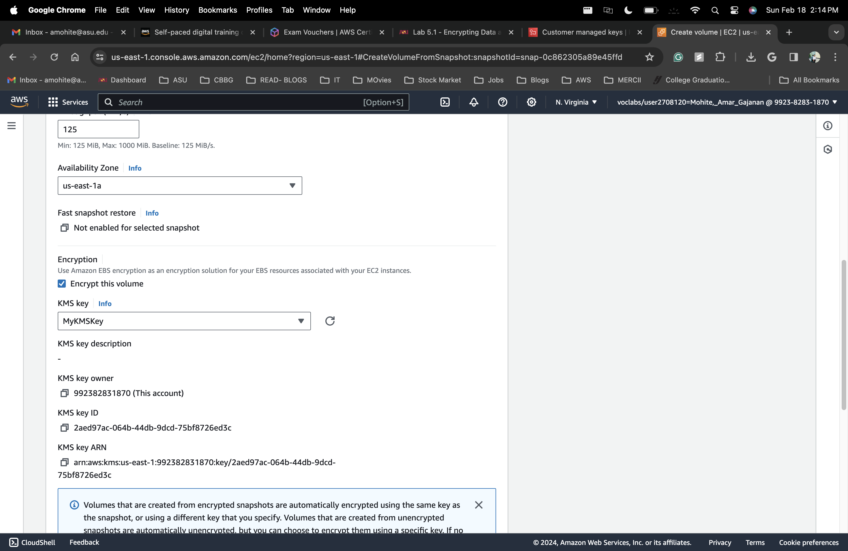

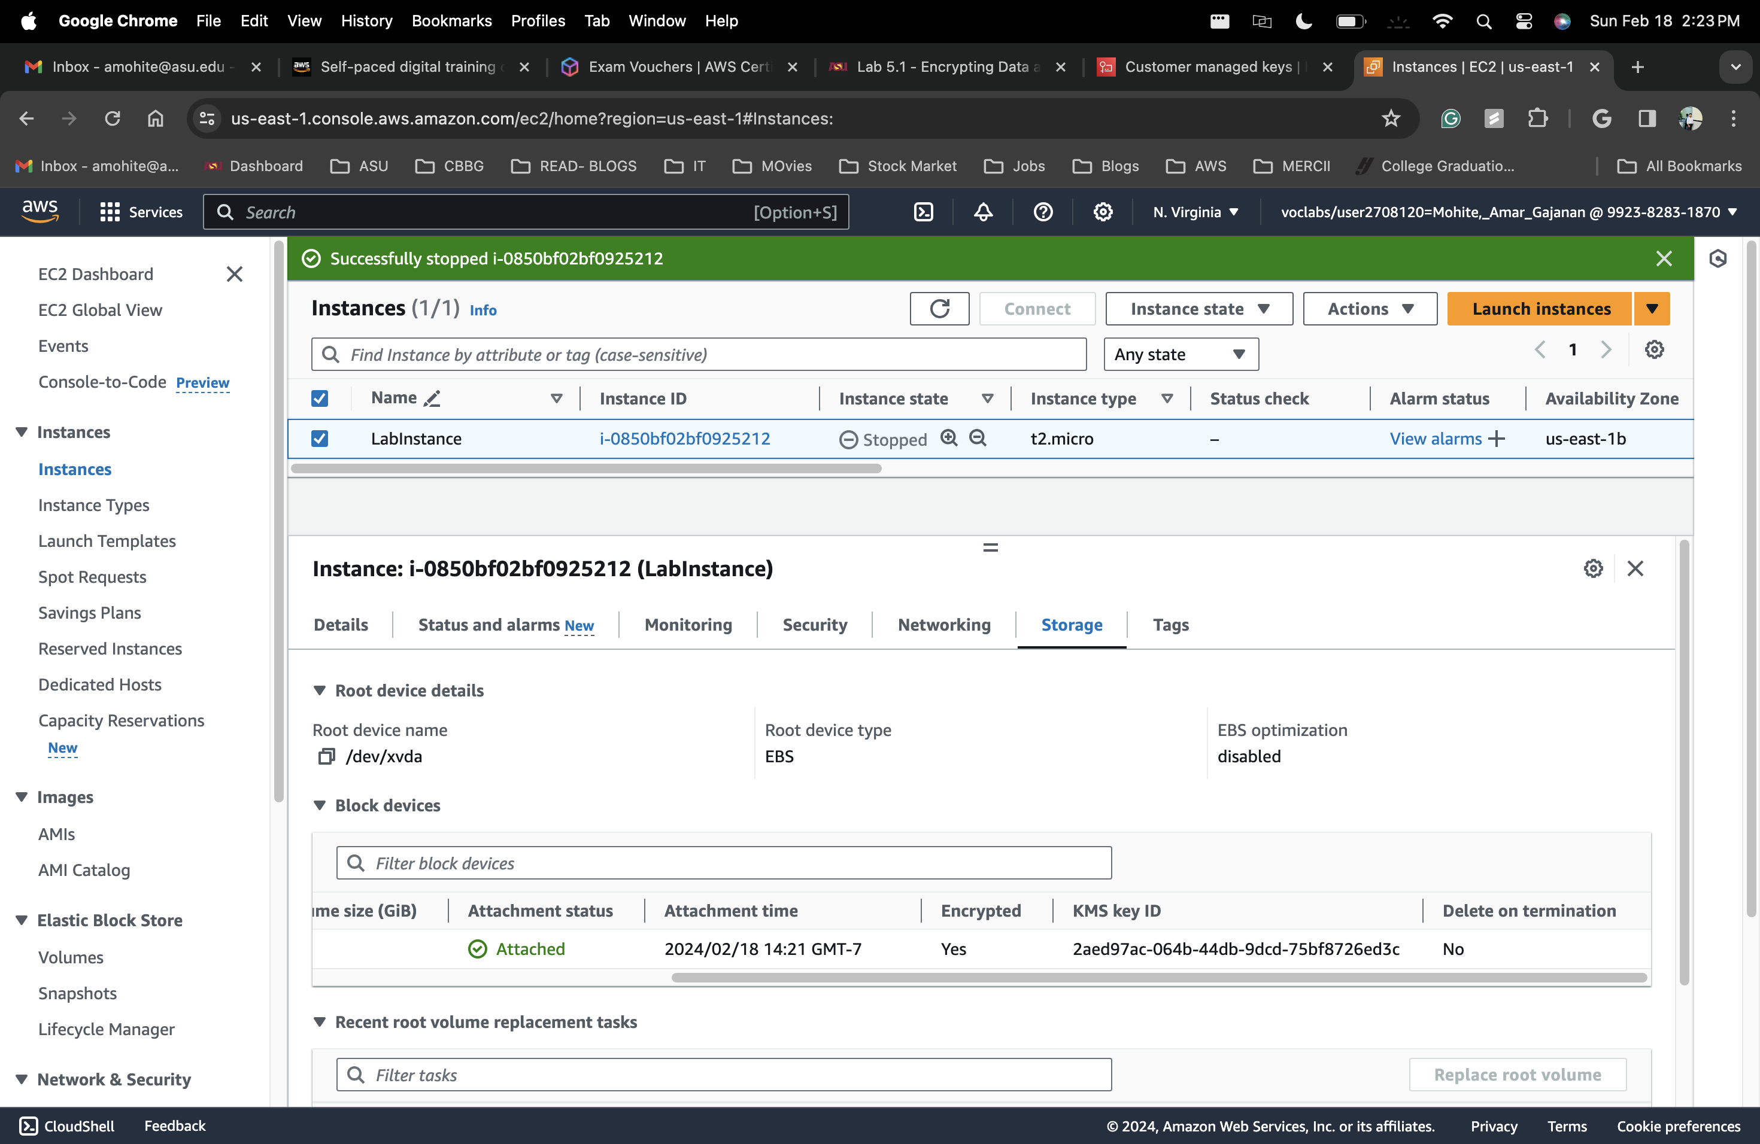

## How to create a SNS topic

1. Lab 6.1
2. Choose **Create topic**, and configure the following:
   1. **Type:** Choose **Standard**.
   2. **Name:** Enter MySNSTopic
   3. Expand the **Access policy - *optional*** section.
   4. **Define who can publish messages to the topic:** Choose **Everyone**.
   5. **Define who can subscribe to this topic:** Choose **Everyone**.
   6. At the bottom of the page, choose **Create topic**.

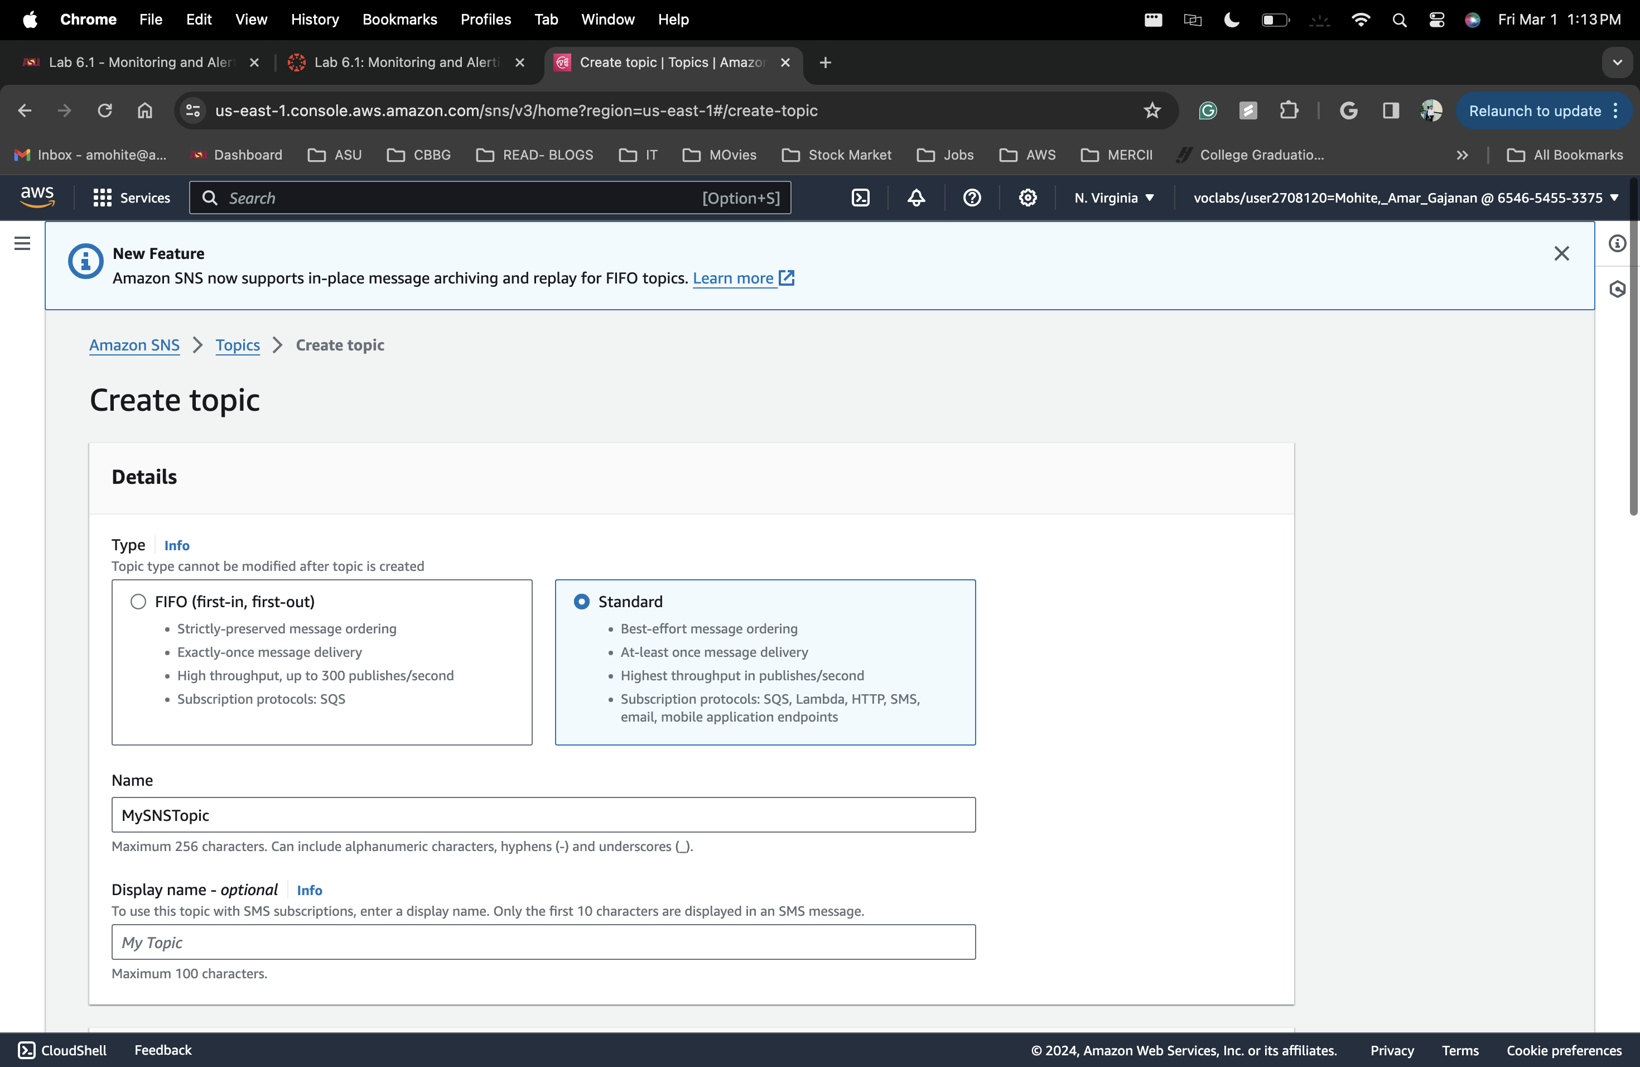

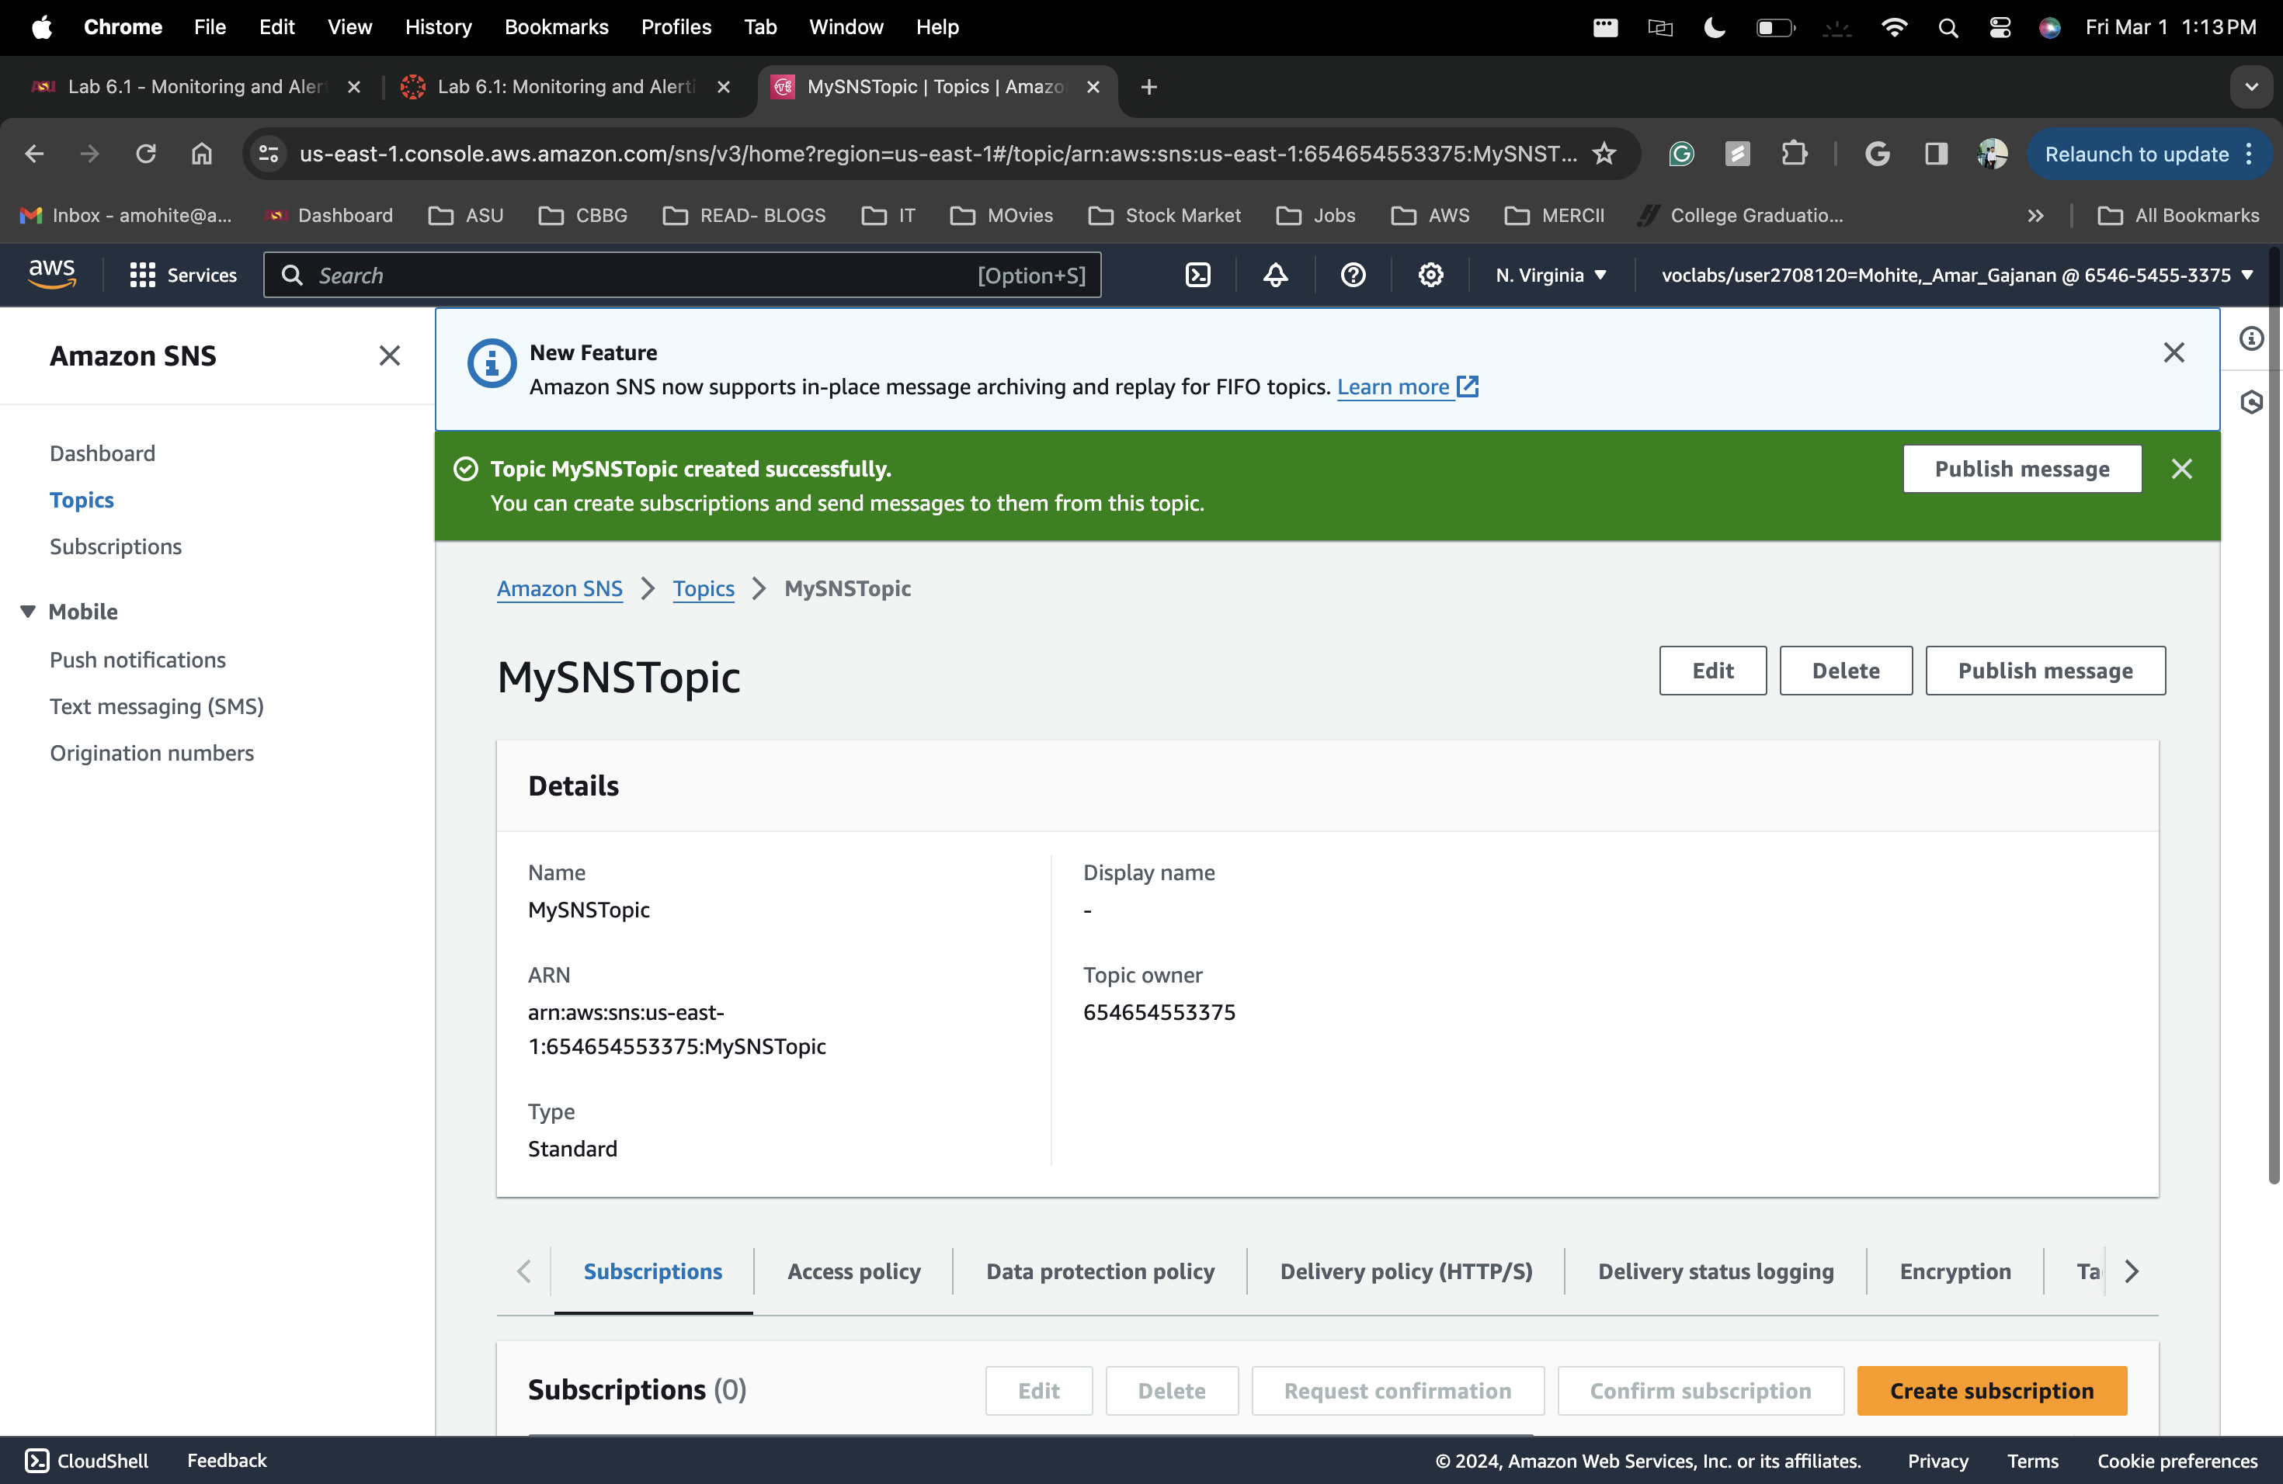

## How to subscribe to a SNS topic

1. Lab 6-1
2. **Topic ARN:** Notice that the Amazon Resource Number (ARN) of the topic that you just created is already filled in.
3. **Protocol:** Choose **Email**.
4. **Endpoint:** Enter an email address where you can receive emails during this lab.
5. Scroll to the bottom of the page, and choose **Create subscription**.

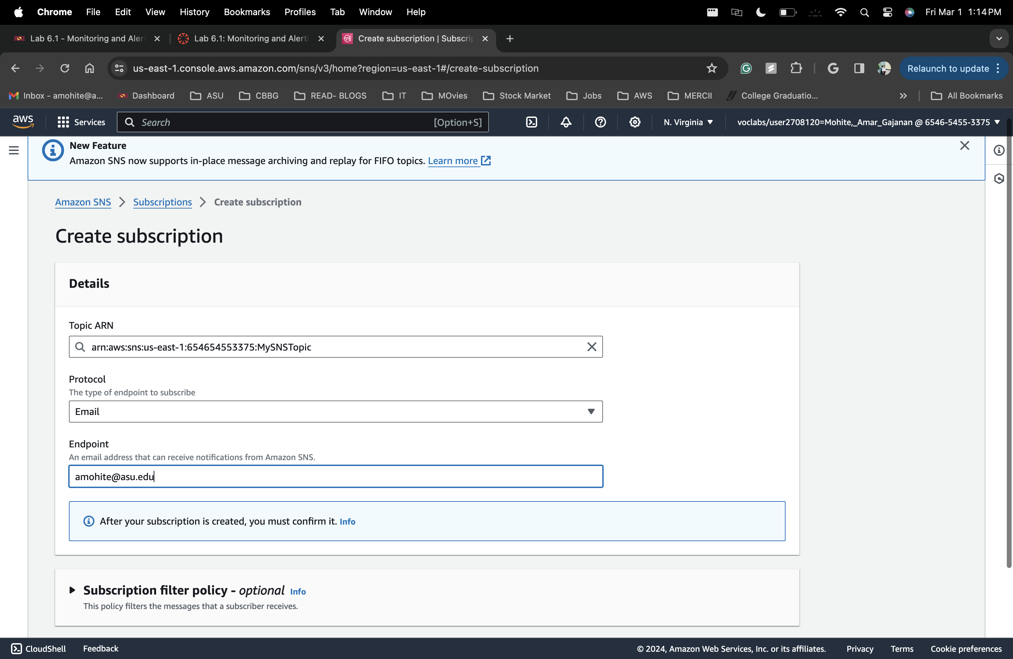

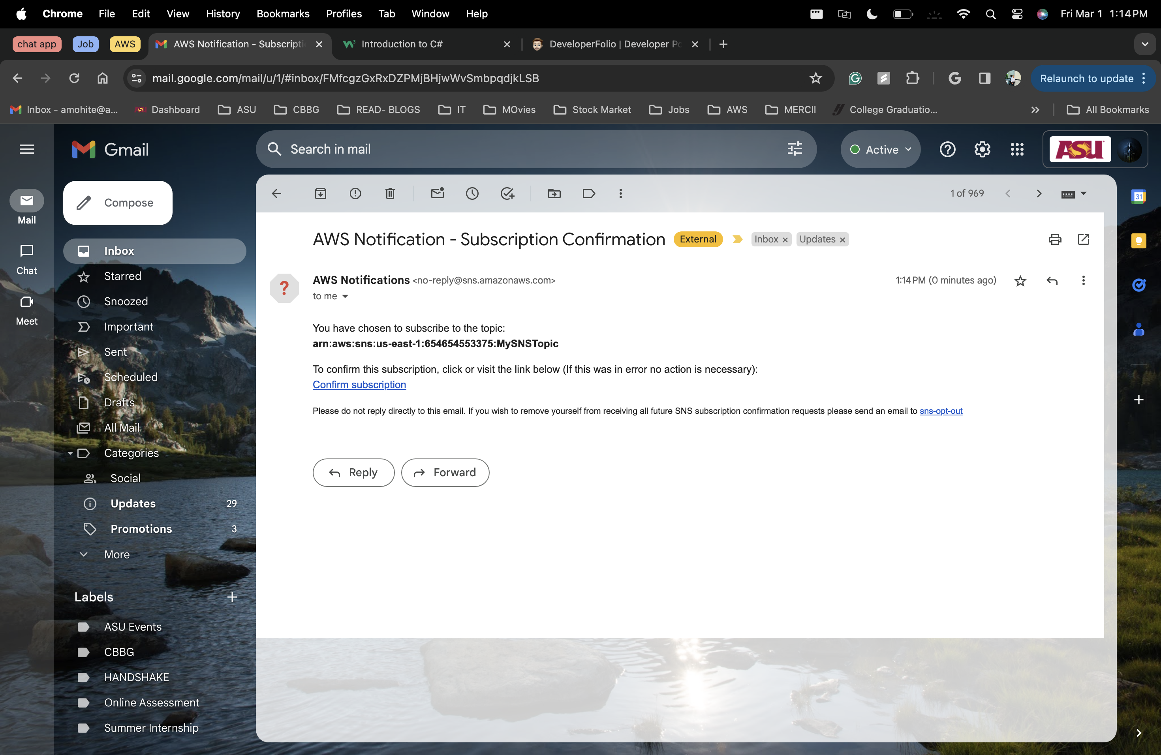

## How to create a CloudWatch alarm using a metrics-based filter

1. Lab 6.1

